Corps-Tribal Lamprey Accords Workgroup (LAW)
  - November 2023 Meeting Agenda
November 16, 2023 09:00-16:00 and November 17, 2023 09:00-14:00
In person: Nixyaawii Governance Center, 46411 Timine Way, Pendleton, Oregon
Webex: https://usace1.webex.com/join/jacob.macdonald

Introductions
CRITFC
Tom Lorz (lort@critfc.org)
*Laurie Porter (porl@critfc.org)
*Greg Silver (gsilver@critfc.org)
YN
*Ralph Lampman (lamr@yakamafish-nsn.gov)
CTUIR
*Aaron Jackson (aaronjackson@ctuir.org)
CTWS
*Lyman Jim (lyman.jim@ctwsbnr.org)
Brad Houslet (brad.houslet@ctwsbnr.org)
JP Patt (jp.patt@ctwsbnr.org)
NPT
*Ray Ellenwood (raymonde@nezperce.org)
*Tod Sween (tods@nezperce.org)
Jay Hesse (jayh@nezperce.org)
CENWW
*Steve Juhnke (steve.d.juhnke@usace.army.mil)
Chris Peery (christopher.a.peery@usace.army.mil)
Travis Foster (travis.g.foster@usace.army.mil)
Ryan Pestes (ryan.pestes@usace.army.mil)
*Liana Aker (liana.m.aker@usace.army.mil)
*Pei Lin Yu (Pei-Lin.Yu@usace.army.mil)
CENWP
Becca Cates (rebecca.i.cates@usace.army.mil)
Bob Cordie (robert.p.cordie@usace.army.mil)
*Andrew Derugin (andrew.g.derugin@usace.army.mil)
Brad Eppard (matthew.b.eppard@usace.army.mil)
Jeanette Flemmer (jeanette.c.wendler@usace.army.mil)
*Karrie Gibbons (karrie.m.gibbons@usace.army.mil)
*Eric Grosvenor (eric.grosvenor@usace.army.mil)
*Craig Johnson (craig.j.johnson@usace.army.mil)
Erin Kovalchuk (erin.h.kovalchuk@usace.army.mil)
*Jacob Macdonald (jacob.macdonald@usace.army.mil)
Tammy Mackey (tammy.m.mackey@usace.army.mil)
Patricia Madson (patricia.l.madson@usace.army.mil)
Nathan McClain (nathan.a.mcclain@usace.army.mil)
Ida Royer (ida.m.royer@usace.army.mil)
*Kyle Tidwell (kyle.s.tidwell@usace.army.mil)
Bob Wertheimer (robert.h.wertheimer@usace.army.mil)
CENWD
*Sean Tackley (sean.c.tackley@usace.army.mil)
Dean Holecek (dean.holecek@usace.army.mil)

Review action items from 8/2 quarterly meeting

ACTION: CRITFC will complete a draft written proposal for adult lamprey trap and transport (aka. LEAPP). USACE will solicit regional feedback on the written proposal in the appropriate technical forum (SRWG, FFDRWG, FPOM, etc.) and initiate policy level discussions.

Porter: The LEAPP document is not ready to be shared as CRITFC /Tribes are still working on the draft document. It nor has it been reviewed by internal policy folks yet.

Lampman: Would like to discuss the possibilities of finding the middle ground here (what can be done in the short term? What is beneficial to have in place now?)
  - Like to see a short term doc and long term doc.

ACTION: When draft proposal for 2024 MCN/JDA juvenile passage and survival study is received, Jake will distribute it to the LAW for review and comment.

Macdonald: Preliminary proposal was received 8/19 and distributed to LAW and SRWG shortly thereafter. It was discussed at the SRWG FY24 AREP Proposal and Work Statement Review Meeting on 9/17. Written comments were received from NMFS and provided to PNNL and LAW for consideration. USACE, LAW, and PNNL met on 10/17 to provide written and verbal comments. PNNL submitted a revised proposal addressing all initial comments on 11/1, we will review the revised proposal with agenda item 5.2 2024 MCN/JDA juvenile passage and survival study (Macdonald).

ACTION: Andrew Derugin and Chris Peery will investigate the feasibility of implementing count station modifications at Bonneville, Lower Granite, **and McNary** count stations. If feasible, CRFM accords funding may be available to implement some fixes immediately.

Continue discussion with agenda item 6.2 Improving window counts at BON, MCN & LWG (Macdonald)

ACTION: Andrew Derugin and Jake Macdonald will investigate the feasibility of implementing Bradford Island control section extensive minor modifications. CRFM accords funding is available to implement some fixes immediately (this Winter), if feasible.

Continue discussion with agenda item 7.2 Bonneville Bradford Island Extensive Minor Mods to the Control Section (Macdonald/Derugin)

ACTION: Jake Macdonald will prepare an adult lamprey passage research summary for the FY25 Anadromous Fish Evaluation Program (AFEP) planning cycle scheduled to begin in February 2024. Objectives to be included holdover rates (where and how long). First detections many years are at upper dams, not Bonneville.

DAY #1: 2020-2024 implementation plan progress

Opening Remarks – your project updates, agenda adds, and/or goals for this meeting

Yakama (Lampman)

Lampman: Prototype floating adult trap (see Lamprey Floatable Collector Photos and Needs.pdf, received from Lampman via email on 11/8). Identify location the trap will be deployed in 2024 and identify responsible parties; seeking Corps advice, expertise, engineers, and assistance with identifying the location, all access and permit issues, structural modification issues, etc. This is a collaborative effort. CRITFC/Tribes are not able to take on the full responsibility of the deployment and anchoring – we need the experts at the dams to provide your advisement and expertise in order for us to successfully deploy the floating trap.
  - 11/8 FFDRWG discussion (see 20231108 NWP-NWW FFDRWG Notes.docx)
    - NMFS thinks the screen mesh is too big.
      - ACTION: Jake will ask Trevor about his comfort level with 1.75”, considering the location is outside the fishway
    - Still need to install sea lion exclusion.
    - Anchoring system needs to be “Engineered” – Derugin
    - Tailrace flux & flexi-pipe is a challenge. Is the flux less at The Dalles?? What is the flux at BON during a couple weeks in July?
  - 11/9 FPOM discussion (see 11/9 FPOM notes)
    - Primary site being considered is BON WA Shore North downstream entrance area.
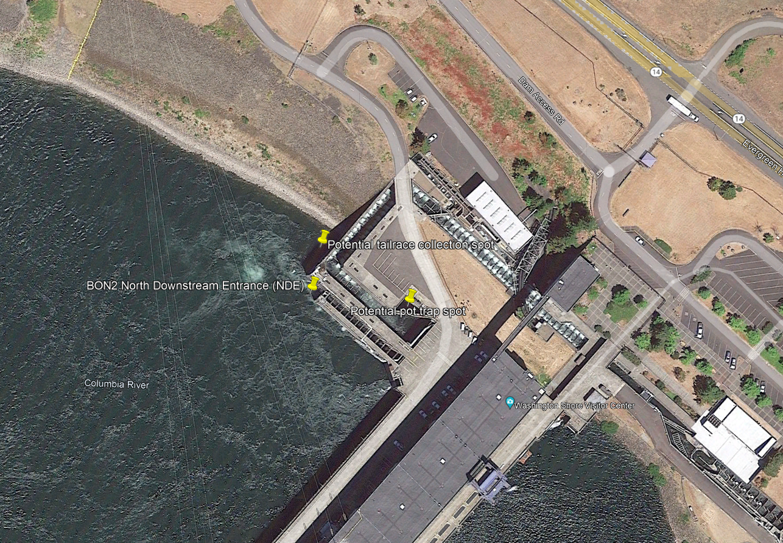
    - Alternate site being considered is TDA East fish ladder east entrance area.
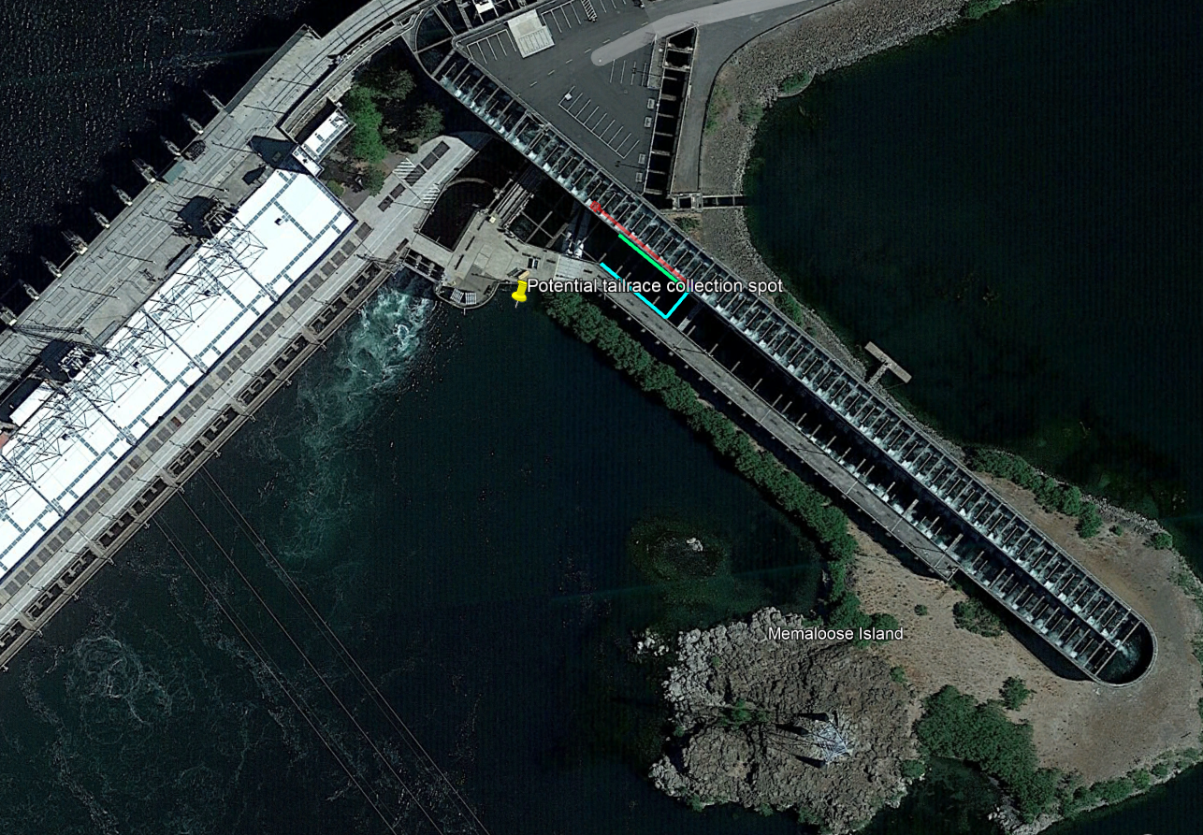
    - From experience with a PIT barge in the past, BPA recommends anchoring in open water is easier than attaching to the dam (less red tape).
    - NMFS prefers no lines in the water.
    - NMFS does not want a structure too close to the shear line from the ladder attraction flow.
    - NMFS expects video monitoring will be used to assure no negative interactions with salmonids or pinnipeds.
  - 11/13 meeting about the Corps’ Section 408 permission process (Macdonald)
    - Section 408 review ensures any activities performed by others on Corps managed lands do not interfere with any Corps missions.
    - CRITFC/Tribes are not proposing significant alterations to the dam structure, not proposing any locations near the navigation channel, and are coordinating fish passage concerns with FFDRWG and FPOM. Section 408 review for the floating collector does not apply but a real estate permit application does apply.
    - Real estate permit can be requested from Jennifer Howard (Portland District Realty Specialist, Bonneville Project and The Dalles Project). Porter is in contact with Howard.
      - CRITFC/Tribes are requesting access to the BON CBB 12 months a year (not just May through September) beginning in 2024 for the purposes of conducting studies, etc.
      - CRITFC/Tribes also intend to begin deploying traps in “expanded locations” in 2024.
        - Macdonald: Is this just the floating trap or are there other expanded locations being considered?
      - Howard (via email 11/7): Corps will require an updated work plan and SOW, as well as maps of the new areas of access. The maps submitted previously were excellent, if you provide something similar again for the tailrace access and any other new areas of access it would be greatly appreciated.
  - Site selection discussion:
    - Sween: Create a “punch list” of stuff that needs to be done/tested in the first year.
      - Upwelling box
      - Pinniped exclusion
      - Anchoring
      - Water/Power
      - Video monitoring
    - Tackley: Phased approach
  - Summarize the pros and cons of Bonneville and The Dalles (Macdonald) – funding to be determined later.
Phase | Bonneville | The Dalles | Responsible Party
Location and Access | CRITFC RE permit app. | CRITFC RE permit app. | CRITFC
In-water work needs for deployment and operation | Tribes/USACE to identify | Tribes/USACE to identify | USACE to research EM-385-1-1 for operating in BRZ
Anchoring (stress the temporary nature) | Outsourced engineering (CRITFC/Tribes or USACE) – BON engineering does not have capacity. | In-house engineering (USACE) – need to reach out | Depends
Upwelling and collection box | Modify JDA’s surplus boxes | Modify JDA’s surplus boxes | Ralph & Jake & Kyle?
Flexi pipe | Tribes to supply | Tribes to supply | CRITFC/Tribes
Pinniped exclusion | Tribes to supply | Tribes to supply | CRITFC/Tribes
Water | LFS pumps (do they work?) | New LPS water supply | USACE?
Power |  |  | USACE
Video monitoring | Required by NMFS | Required by NMFS | CRITFC/Tribes
  - Decide on which location to put in the Real Estate permit application for 2024 (CRITFC/Tribes)
    - Macdonald: My opinion, we put The Dalles in the RE permit app for 2024 but do not lose sight of the ultimate preferred location at BON WA shore in 2025.
    - Tackley: “Serious” engineering support from the Corps would require sufficient funding in 2024. May not be able to use CRFM funds for this, need to be “creative”.
    - Lampman: Wherever we can put it in. Supports The Dalles but prefers Bonneville.
    - Sween/Ellenwood: Can we apply for both? Plan on moving to BON maybe mid-season?
    - Ellenwood: Concerned there are less fish available at The Dalles
    - Jackson: The Dalles. Start at the entrance, not the boat dock. CBB testing in April will check a lot of things off.
    - Porter: In agreement with Aaron.
    - Derugin: Start at The Dalles, but wants it at Bonneville someday
    - Jim: Agrees with the group. Concerned about the hydraulics of the entrance area.
    - Grosvenor: Consider this location near the JBS outfall on the South shore of John Day. We can get water there and put a trap box close by. You couldn’t deploy until after 15 June because tailrace would be too unpredictable during spring spill operations.
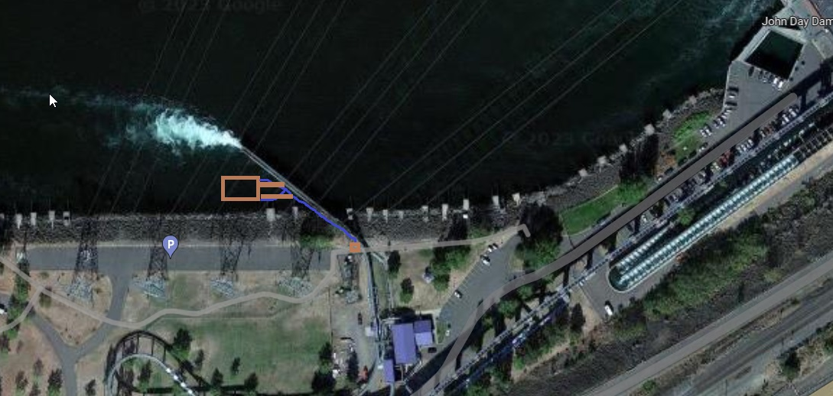
    - ACTION: Jake will set up a field trip to inspect potential deployment locations at The Dalles and John Day.
  - Laurie will revise the RE permit application. Jake offered to proofread prior to submittal.

Lampman: Design ideas for future consideration
  - Here is my entrance structure design (appreciate feedback/input): The pipe/hose floats and goes up and down based on the flow level and provides the trickle of water right at the entrance and hoping the structure will provide cover / resting place and they find that trickle of water to go up.
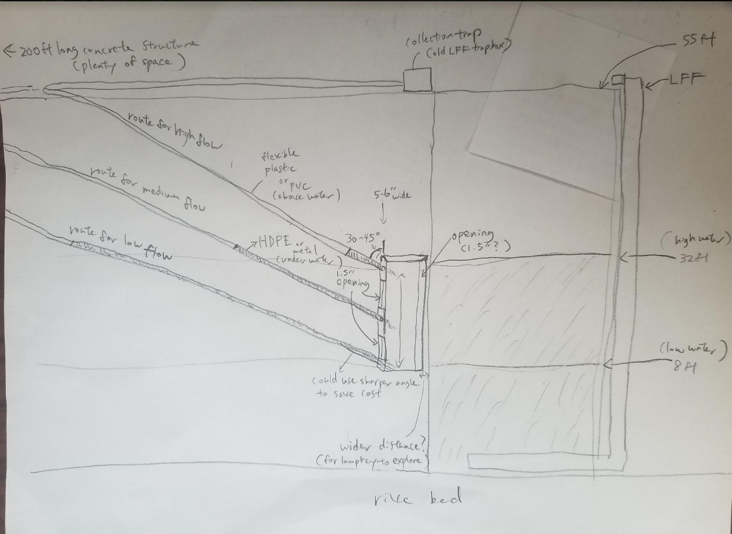
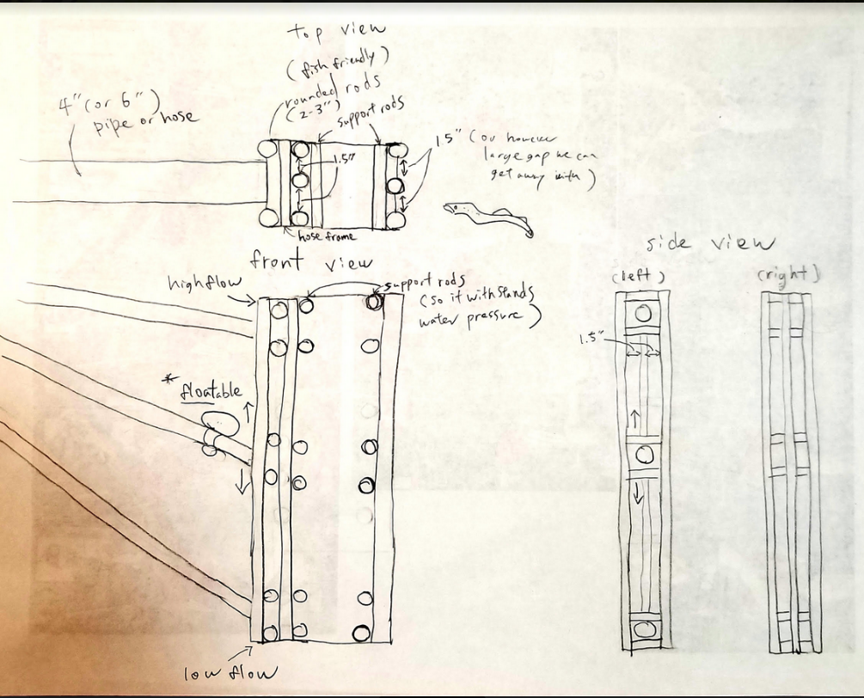
  - An updated design (some feedback from Jim) – one lamprey passage tube at the bottom and attraction flow at the top
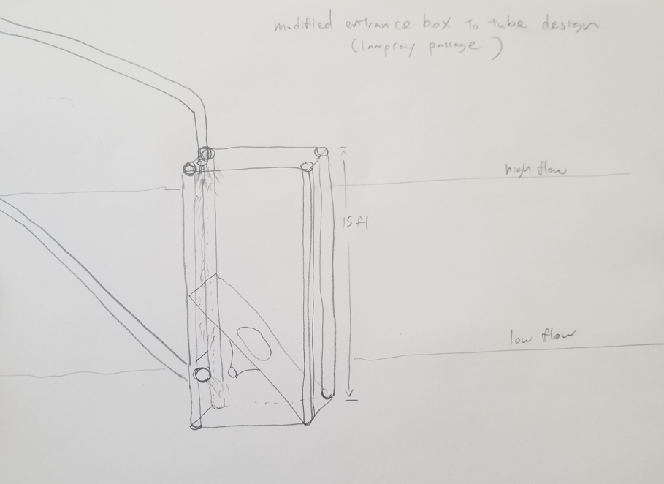
  - Lampman: Finally, this may not apply to large hydro dams, but a structure to help create less flow at dam surface (or similar structures):
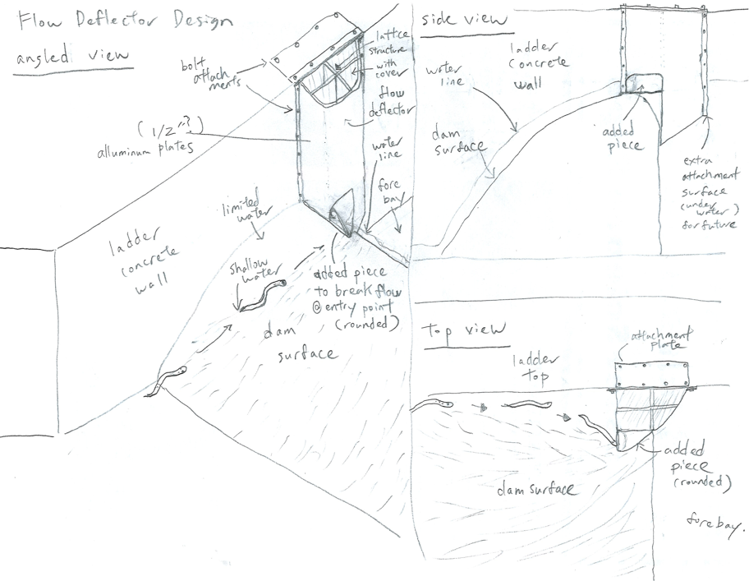
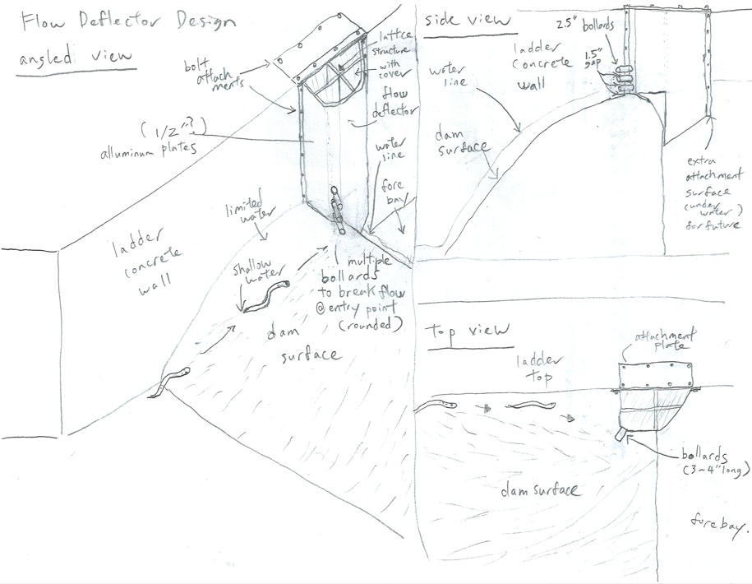

Umatilla (Jackson)

Communication norms. Access to Corps calendar of meetings etc.

Planning for 2025, Washington Shore

Warm Springs (Jim)

Nez Perce (Sween)

Moving the LEAPP program forward to implementation; predation studies, all of the above.

CRITFC (Porter)

LEAPP update; floating trap; communication; tracking multiple conversation streams is tricky; location for the floating trap; predation study (Cramer) responsibilities.

2023 translocation summary
  - 11,003 total. Record!

2024 translocation planning (access needs, permits, etc.)

NWD (Tackley)

Improving communication and coordination within the LAW (Tackley has a Word doc started that we can walk through with the team on Friday)

NWW (Juhnke/Aker)

Aker: Learning opportunity, getting more comfortable.

Yu: Tribal Liaison fields fly balls that need to be elevated to G2G consultation. LAW seems to be working well but let her know if something needs to be elevated.

NWP (Kovalchuk/Macdonald)

Location for the floating collector.

FY 2020 Work Plan Programmatic Budget Summary and Forecast (Kovalchuk Friday only)

Pacific Lamprey Passage Improvements Implementation Plan refresher (Macdonald)
  - 2008 Columbia Basin Fish Accords MOA
    - $50M spent 2008-2018 researching fishway bottlenecks, monitoring lamprey passage behavior, and constructing/evaluating experimental passage structures.
  - 2018 Fish Accords extension MOA
    - Corps committed to seek funding to continue to improve Pacific Lamprey passage conditions at Corps dams.
  - 2018-2020
    - “Funding gap”
    - Coordinated with Tribes and CRITFC developing and prioritizing a list of actions, should funding be received to implement 2018 Accords extension.
  - 2020
    - Received funding to implement the measures from the 2018 Accords extension
  - March 2021
    - Implementation plan finalized
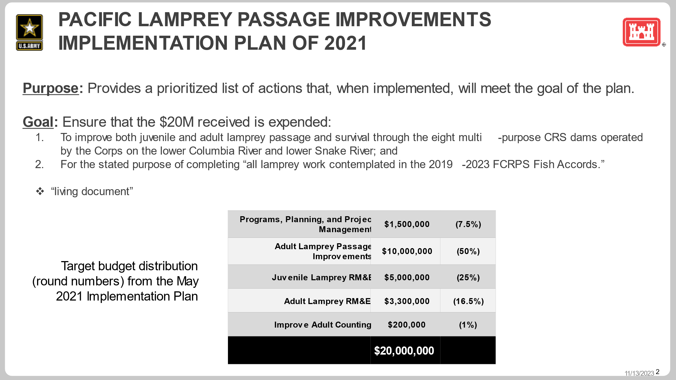

USACE budget cycle refresher (Kovalchuk)
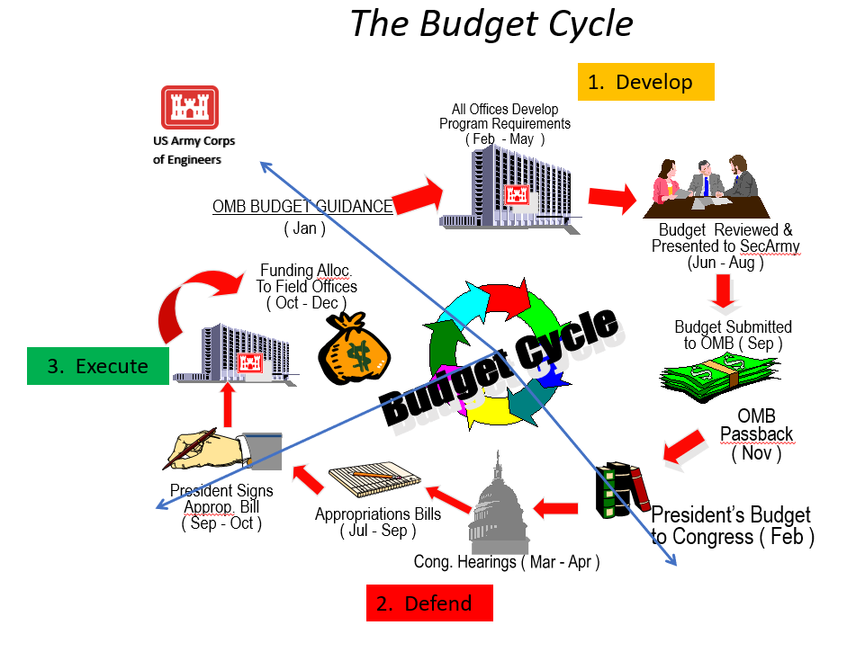
  - Numbers can’t be shared outside the Corps until the President signs the PBUD. Can share as a list of activities with no $$.
  - Erin is working on FY 26 request now (capability). Won’t know for 2 years if it gets funded.
  - Currently targeting roughly ~$5 million per year in expressed capability.
  - Various opportunities within this cycle for partners to advocate for priorities and additional capability.
  - Limited ability for the Corps to “staff up” for short-term additional capability.
  - Execution levels in FY23 and FY24 helps to make a case for growing the program, consider expressing capability for more than ~$5 million in the future.

What have we spent and what do we have to show for it? (Kovalchuk/Macdonald)
Implementation Plan Line Item | FY 2020-2022 Executed | FY 2023 Executed
Adult Passage Improvements | $ 2,212,096 | $ 5,292,529
BN2 WAS control section redesign (CRSO) | $ 501,990 | $ 725,575
BN1 B-Branch entrance improvements (CRSO) | $ 720,358 | $ 1,912,086
TDA EFL Junction Pool LPS (CRSO) | $ 442,652 | $ 2,037,432
JDA NFL entrance LPS improvements (CRSO) | $ 359,321 | $ 257,719
MCN weir caps (CRSO) | $ 78,527 | $ 282,953
BN1 BI serpentine extensive minor mods (& curtains) | $ - | $ 4,594
BN2 CI LPS flume modification | $ - | $ -
BN2 WAS LPS pump upgrade | $ 56,969 | $ 1,900
JDA SFL SE1 weir improvement | $ - | $ 49,618
JDA NFL VWW plating | $ 21,752 | $ 10,497
BN1 B-Branch orifice ramps and diffuser plating (CRSO) | $ - | $ -
JDA SFL collection and counting improvement | $ 16,353 | $ -
BN2 WAS LFS modification | $ 14,174 | $ -
BN2 CI orifice ramps and diffuser grating plates (CRSO) | $ - | $ 10,155
LMN NFL diffuser grating plating (CRSO) | $ - | $ -
BN2 WAS Junction Pool LPS (CRSO) | $ - | $ -
BN2 WAS wetted wall (CRSO) | $ - | $ -
JDA SFL LPS (CRSO) | $ - | $ -
BN1 BI LPS pump upgrades | $ - | $ -
Juvenile Lamprey RM&E | $ 1,191,166 | $ 2,639,677
Juvenile Passage and Migration RM&E Plan | $ 1,154,093 | $ 2,546,844
ICH turbine cooling water strainer (CRSO) | $ 37,074 | $ 92,833
Programs, Planning, and Coordination | $ 797,914 | $ 326,062
Program Management and Coordination Labor | $ 797,914 | $ 326,062
Improve Adult Counting | $ 44,779 | $ 97,157
Improve Adult Counting at BON LPS's | $ 44,779 | $ 97,157
Adult Lamprey RM&E | $ - | $ -
Diffuser Grating Assessment | $ -
Adult lamprey passage & migration RM&E | $ - | $ -
Grand Total | $ 4,245,956 | $ 8,355,425

What do we have left and how do we propose to spend it? (Kovalchuk/Macdonald)

Forecast values are changing daily (Kovalchuk)
  - Contract modifications for BN1 B-Branch entrance improvements and TDA EFL Junction Pool LPS
  - Juvenile Passage and Migration RM&E Plan: Have funding for McNary & John Day (2024), may not have enough for The Dalles & Bonneville (2025)
  - ACTION: Kovalchuk will revise the numbers in the table below and report back with a clear picture of any available funding for additional high priority actions.
Implementation Plan Line Item | FY 2020-2022 Executed | FY 2023 Executed | FY 2024 Forecast | Total Forecasted FY20->FY24
Adult Passage Improvements | $ 2,212,096 | $ 5,292,529 | $11,500,000 | $ 19,004,625
BN2 WAS control section redesign (CRSO) | $ 501,990 | $ 725,575 | $1,000,000 | $ 11,227,565
BN1 B-Branch entrance improvements (CRSO) | $ 720,358 | $ 1,912,086 | $645,000 | $ 3,277,444
TDA EFL Junction Pool LPS (CRSO) | $ 442,652 | $ 2,037,432 | $500,000 | $ 2,980,084
JDA NFL entrance LPS improvements (CRSO) | $ 359,321 | $ 257,719 | $0 | $ 617,040
MCN weir caps (CRSO) | $ 78,527 | $ 282,953 | $0 | $ 361,480
BN1 BI serpentine extensive minor mods (& curtains) | $ - | $ 4,594 | $200,000 | $ 204,594
BN2 CI LPS flume modification | $ - | $ - | $125,000 | $ 125,000
BN2 WAS LPS pump upgrade | $ 56,969 | $ 1,900 | $0 | $ 58,869
JDA SFL SE1 weir improvement | $ - | $ 49,618 | $0 | $ 49,618
JDA NFL VWW plating | $ 21,752 | $ 10,497 | $0 | $ 32,249
BN1 B-Branch orifice ramps and diffuser plating (CRSO) | $ - | $ - | $20,000 | $ 20,000
JDA SFL collection and counting improvement | $ 16,353 | $ - | $0 | $ 16,353
BN2 WAS LFS modification | $ 14,174 | $ - | $0 | $ 14,174
BN2 CI orifice ramps and diffuser grating plates (CRSO) | $ - | $ 10,155 | $0 | $ 10,155
LMN NFL diffuser grating plating (CRSO) | $ - | $ - | $10,000 | $ 10,000
BN2 WAS Junction Pool LPS (CRSO) | $ - | $ - | $0 | $ -
BN2 WAS wetted wall (CRSO) | $ - | $ - | $0 | $ -
JDA SFL LPS (CRSO) | $ - | $ - | $0 | $ -
BN1 BI LPS pump upgrades | $ - | $ - | $0 | $ -
Juvenile Lamprey RM&E | $ 1,191,166 | $ 2,639,677 | $3,482,994 | $ 7,313,837
Juvenile Passage and Migration RM&E Plan | $ 1,154,093 | $ 2,546,844 | $3,472,994 | $ 7,173,930
ICH turbine cooling water strainer (CRSO) | $ 37,074 | $ 92,833 | $10,000 | $ 139,907
Programs, Planning, and Coordination | $ 797,914 | $ 326,062 | $250,000 | $ 1,373,976
Program Management and Coordination Labor | $ 797,914 | $ 326,062 | $250,000 | $ 1,373,976
Improve Adult Counting | $ 44,779 | $ 97,157 | $50,000 | $ 191,936
Improve Adult Counting at BON LPS's | $ 44,779 | $ 97,157 | $50,000 | $ 191,936
Adult Lamprey RM&E | $ - | $ - | $0 | $ -
Diffuser Grating Assessment | $ - |  | $0 | $ -
Adult lamprey passage & migration RM&E | $ - | $ - | $0 | $ -
Grand Total | $ 4,245,956 | $ 8,355,425 | $5,282,994 | $ 17,884,375
  - The Dalles slot covers may not get installed until next winter.
  - Q: When will we know final costs of the contracts? A: When the contracts are executed, after the IWW. ~4 months for final billing.
  - ACTION: Kyle/Jake will produce a SSB for predation study contribution from USACE for Erin to consider.
    - Scope= Dam angler sample collection and analysis/reporting. (Update an existing document from 2 years ago)

How are we “seeking” additional funding? (Kovalchuk/Macdonald)

Responded to an information request from USACE HQ calling for additional CRFM capability in FY 2024:
  - We responded that we could execute a construction contract for the WA Shore control section redesign in Fiscal Year 2024 if we had $10 million added to our 2024 CRFM budget.
  - The response back was positive. We expect to receive additional funding for the WA Shore control section construction when the FY24 budget passes congress.

Expressed capability in the FY 2025 budget request for:
  - Adult/juvenile & larval RM&E (post-construction evaluation of WA Shore, if constructed in 2024)
  - Design work for two new LPSs at Bonneville Washington Shore and John Day
  - Additional extensive minor mods to the Bradford Island serpentine section in Winter 2025-2026
  - Continued program coordination

Juvenile Lamprey RM&E

2023 LWG/LMN juvenile passage and survival study (Juhnke/Aker)
  - PNNL will provide some preliminary results soon, Steve will send to LAW.
  - Some tags assembeled but not used, some not assembled. Steve will report actual numbers soon
  - Tags not assembled should be available in 2024.
  - Jackson: Have we already paid for assembly of those tags?
  - Sween: Slug of fish came down days after we called it for the year the first week of November.
  - Lower than expected number of detections, PNNL is performing additional QC.
  - Porter: Presentation of preliminary results from PNNL? AFEP annual review in January would work.

2024 MCN/JDA juvenile passage and survival study (Macdonald)

Review attachment 83024 SOW.pdf
  - First page still says “juvenile and _ lamprey”
  - Collections table: include more months
  - “No tagging of lamprey will occur during the fall in 2024.” Be more flexible?
  - “Tagged lamprey will be released just after dusk” . Want to make sure that means “dark”.

Ice Harbor turbine cooling water strainer prototype (Juhnke/Aker)

Survey crew site visit to unit 4 to get exact dimensions. Unit 4 is identical to unit 6, where we plan to install the cover in Oct 2024.
  - Jackson: How do we accelerate this work? Going to take forever!
  - Coordination with hydro takes time
  - Consensus with fish managers takes time
  - Turbine replacement is a year behind schedule
  - Unknowns in the outage schedule, at the mercy of the maintenance schedules
  - ACTION: We need a turbine cooling water exclusion implementation plan! Chuck and Liana are on point. 2nd quarter FY 2024. Tackley offered to help get started. Which units are available which years, include cost estimates. Liana, Sean, Jake and Steve will “huddle”.

Lampman: Predation study proposal
  - See attached 2024 PLCI BPA Lamprey Funds_CR Predation Study.pdf provided by Lampman via email on 10/28.
  - Objectives:
  - 1. Identify key invasive fish species preying on juvenile/larval lamprey in the CR, shedding light on which species pose the greatest threat.
  - 2. Determine key locations in the CR where predation occurs most frequently, helping managers target conservation efforts effectively.
  - 3. Pinpoint the temporal timing when predation is most prevalent and intense, facilitating development of strategic dam operations.
  - 4. Collaborate with ongoing studies that employ lethal predator monitoring or readily collect predator species data to minimize costs.
  - Methodology:
  - Sample Collection: Cramer Fish Sciences and tribal partners will collaborate with USACE/BPA/WDFW/ODFW/PSMFC to collect predator fish carcasses and stomach contents at The Dalles, John Day, and McNary dams from March~July 2024, ensuring the desired number and species distribution of samples.
  - Sample Preparation and Lab Analysis: Cramer Fish Sciences and partners will process and prepare the samples according to handling and shipping protocols (GENIDAQS). GENIDAQS will conduct multiple species metabarcoding analysis on 200 total samples.
  - Results and Reporting: USACE and partners will compile the laboratory analysis results and produce a comprehensive report, explaining the findings related to the project's objectives.
  - Budget:
  - The requested budget for the pilot study is $68,124. The total cost share provided by partners/collaborators is estimated to be $91,174, including labor, services, and matching costs. The overall goal is to conduct a study using ~400 samples; the PLCI requested funds will cover approximately 50% of this overall needs. The partners plan to utilize other funding sources (e.g., McNary Mitigation Funds, ACOE, BIA and existing BPA funds) to fully meet the project scope and goals.

2024 juvenile lamprey predation research summary (Macdonald/Lampman)

Work done to date (Lampman)

Proposed work in 2024 (Macdonald/Lampman)

Modeling techniques to analyze migratory juvenile fish distributions in the CRS (Tidwell)

INSERT KYLE’S SLIDES

Adult counting

BON LPS counting improvements implemented for 2023 (Tidwell)

INSERT KYLE’S SLIDES

Improving window counts at BON, MCN & LWG (Macdonald)

Macdonald: Saw a presentation recently from RJ Bottaro (USFWS Red Bluff F&W Office) working on a small dam in Northern California. He constructed a “lamprey ramp” (more appropriate to call it a “hurdle” I think) to encourage lamprey to pass higher in the window where they’re easier to count. We have similar issues, can we do this too?
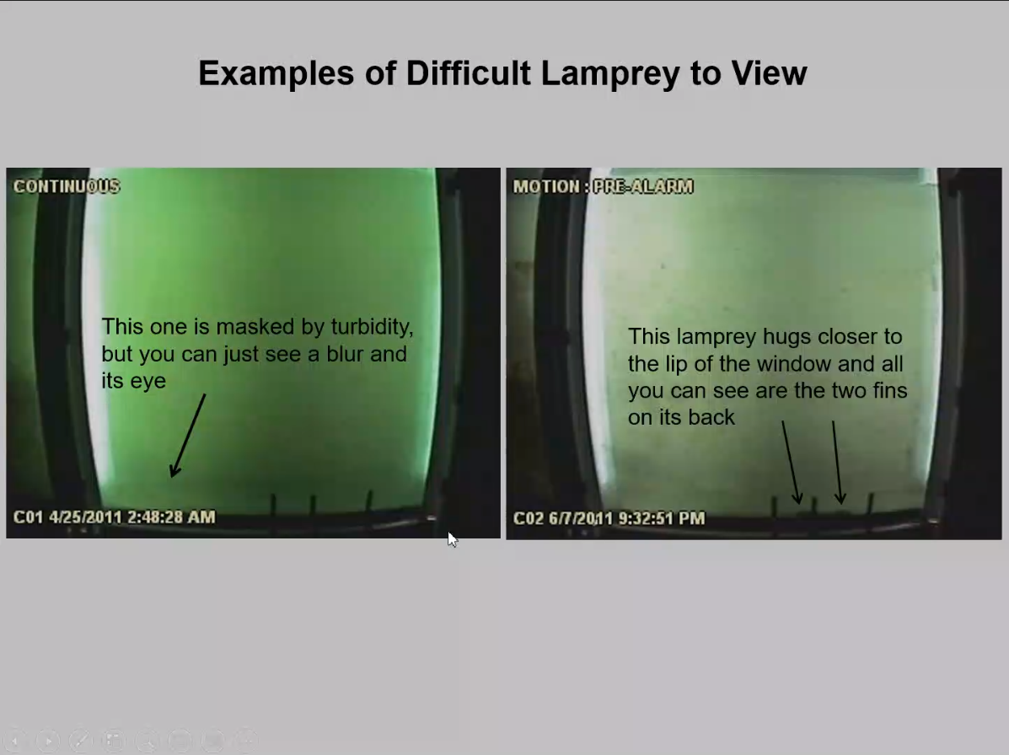
RJ’s design technique reminds me of someone I know…😉
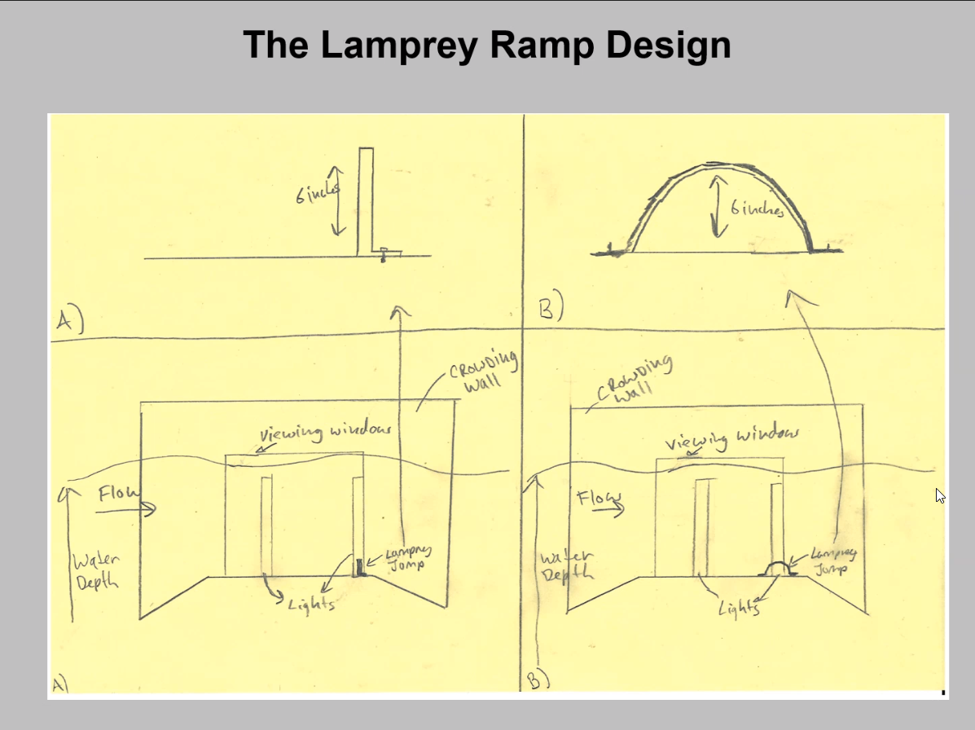
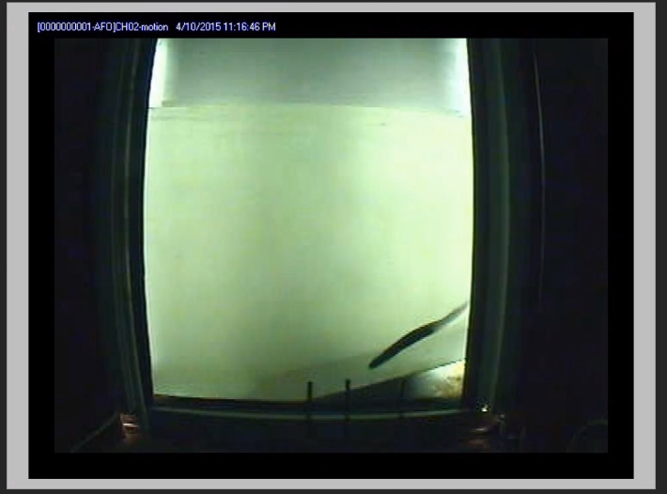

Lamprey SMART panel R&D (Macdonald/Lampman?)
  - Possible applications at wetted walls? Picket leads?
  - Porter: Took CRITFC off this proposal.
  - Lampman: is still on the proposal and will report back with any significant developments.
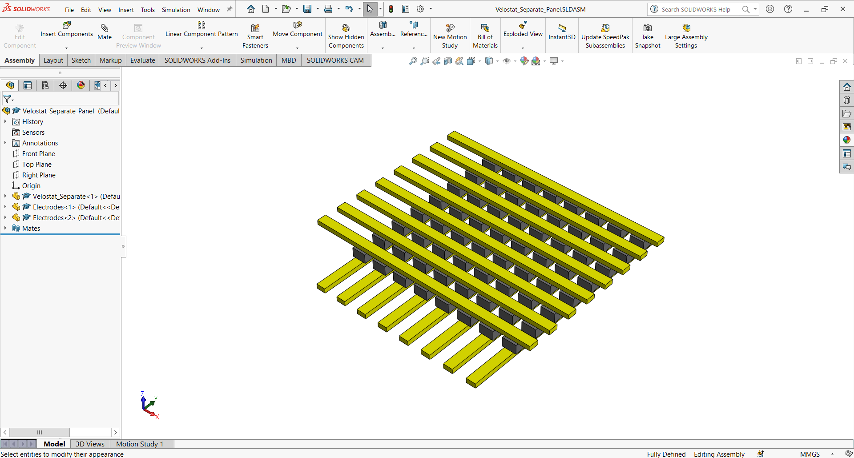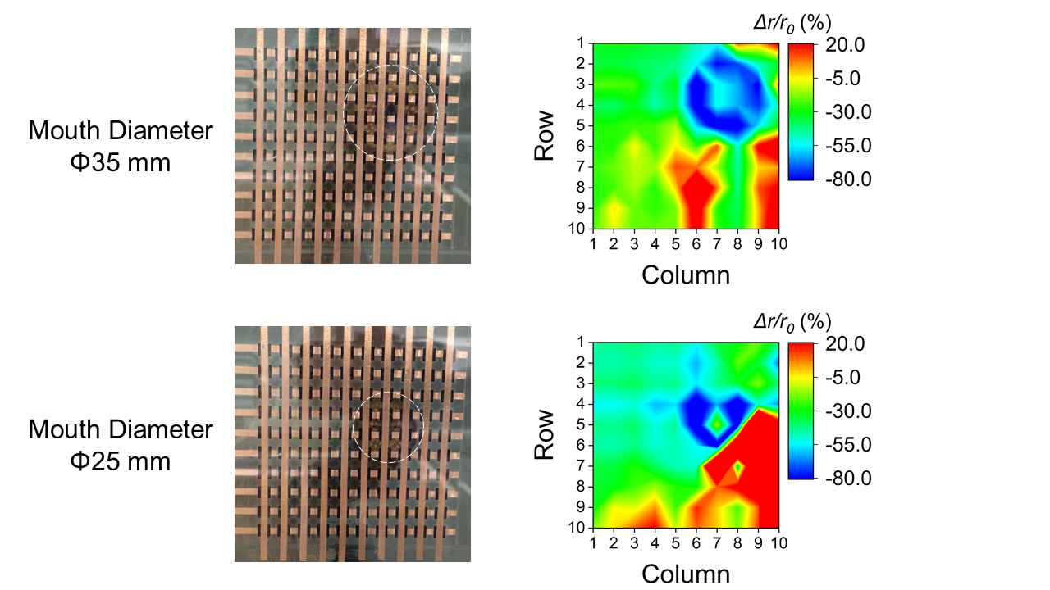
Copper Tapes
Force-sensitive film patches
Lamprey mouth
Pressure profile
of mouth rim

(a)
(b)
(c)
Figure 1: (a) Schematic of basic sensor structure; (b) a sea lamprey sucking at the sensor panel (in the back); (c) the resulting pressure profile, clearly showing the high pressure (compression) region corresponding to the lamprey mouth [1].

Yakama Tribe is proposing converting to optical counters at Prosser. Glad to hear it’s going well at Corps dams.

Adult Lamprey Passage Improvements

Bonneville B-Branch Entrance Improvements (Macdonald/Kovalchuk)

90% DDR available on FFDRWG website: https://pweb.crohms.org/tmt/documents/FPOM/2010/FFDRWG/FFDRWG.html
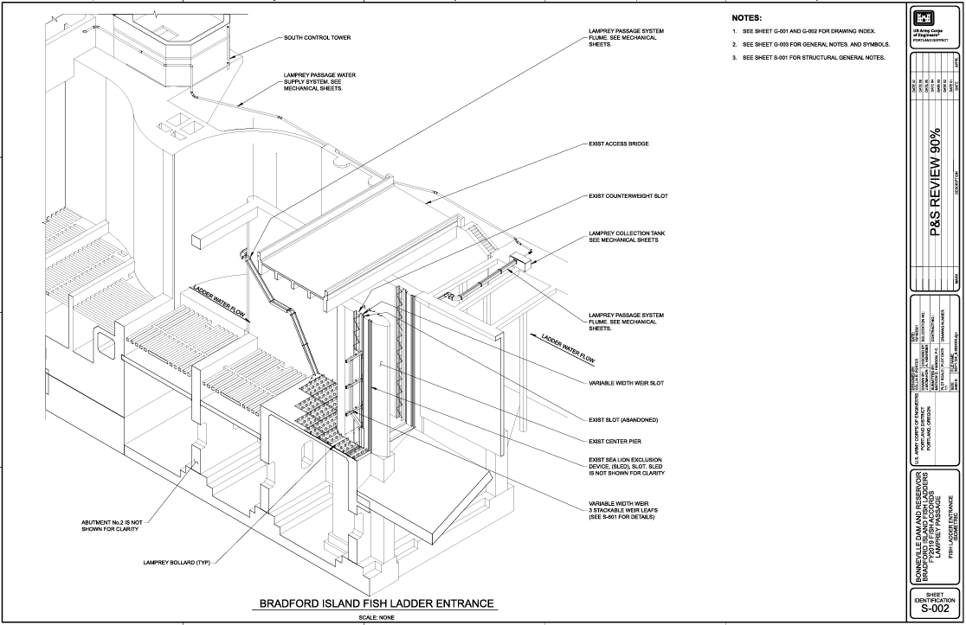

Bonneville Bradford Island Extensive Minor Mods to the Control Section (Macdonald/Derugin)

Macdonald: Goal for this project is to (attempt to) provide lamprey passage features in the Bradford Island control section that are comparable the features of the new Washington Shore control section, but for a fraction of the cost. Key lamprey passage features of the new Washington Shore Control Section include:
  - straighter, shortened swim path
  - floor-level orifices and refuge boxes for bottom-oriented fish
  - rounded corners for wall-oriented fish
  - vertical slots for surface-oriented fish
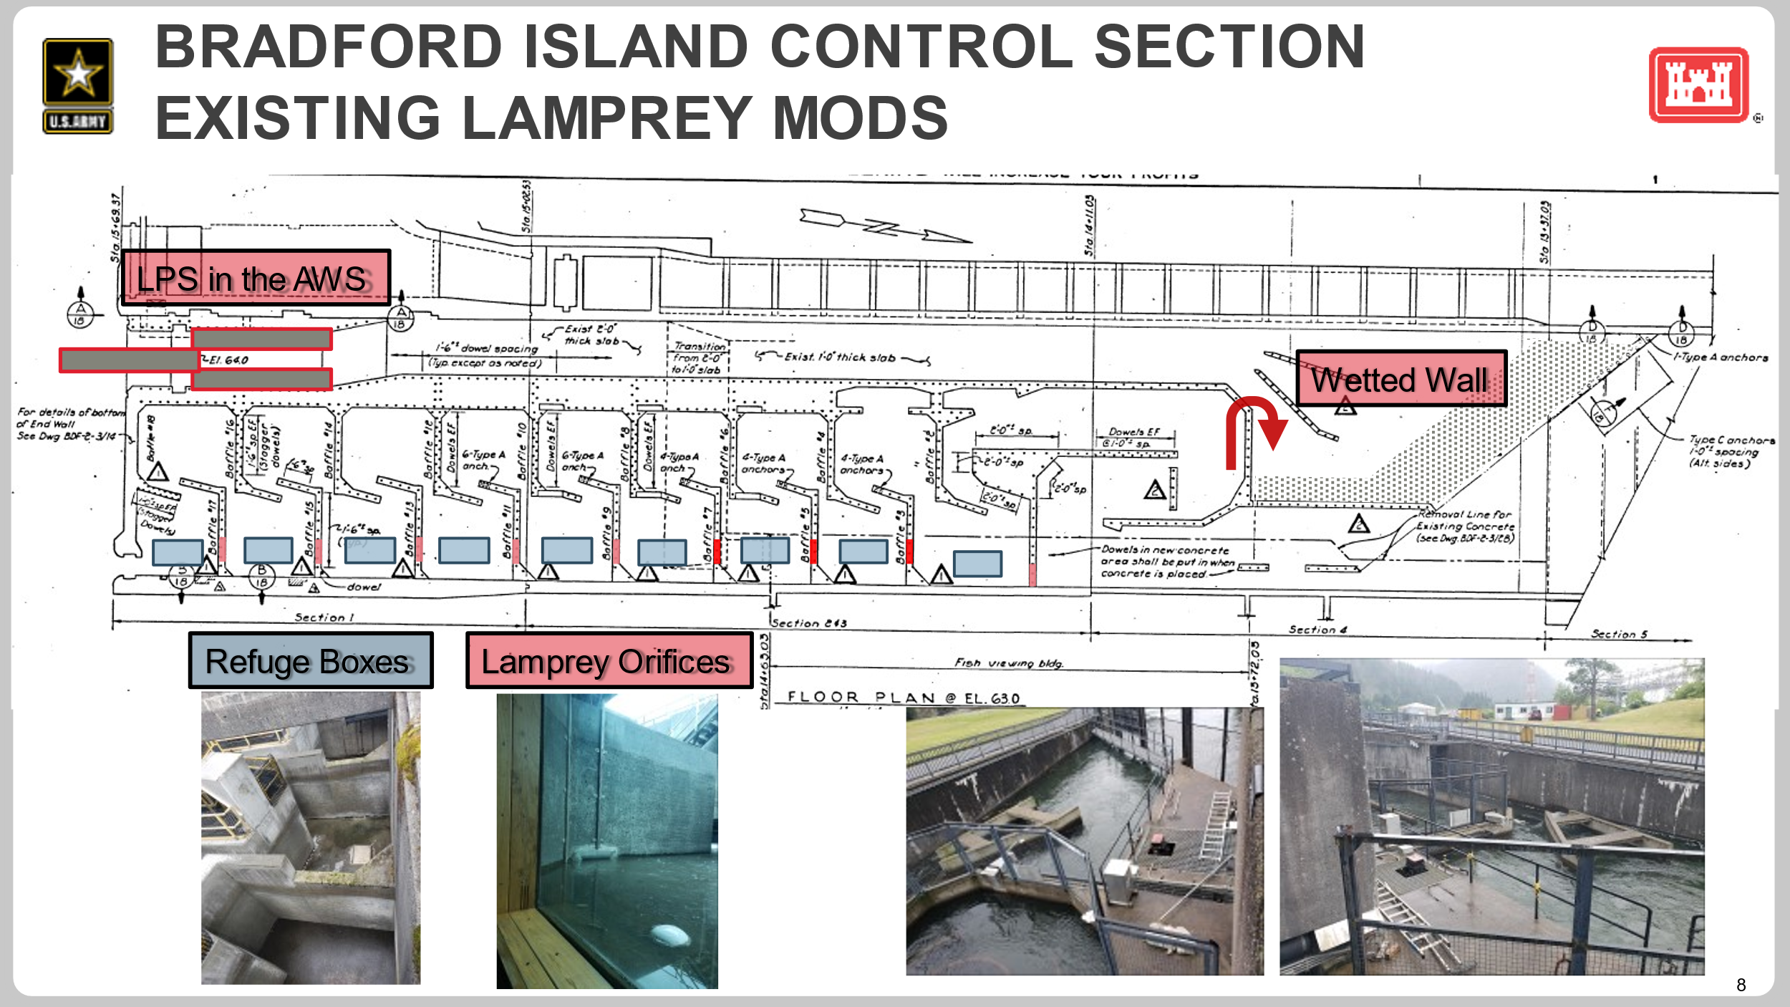
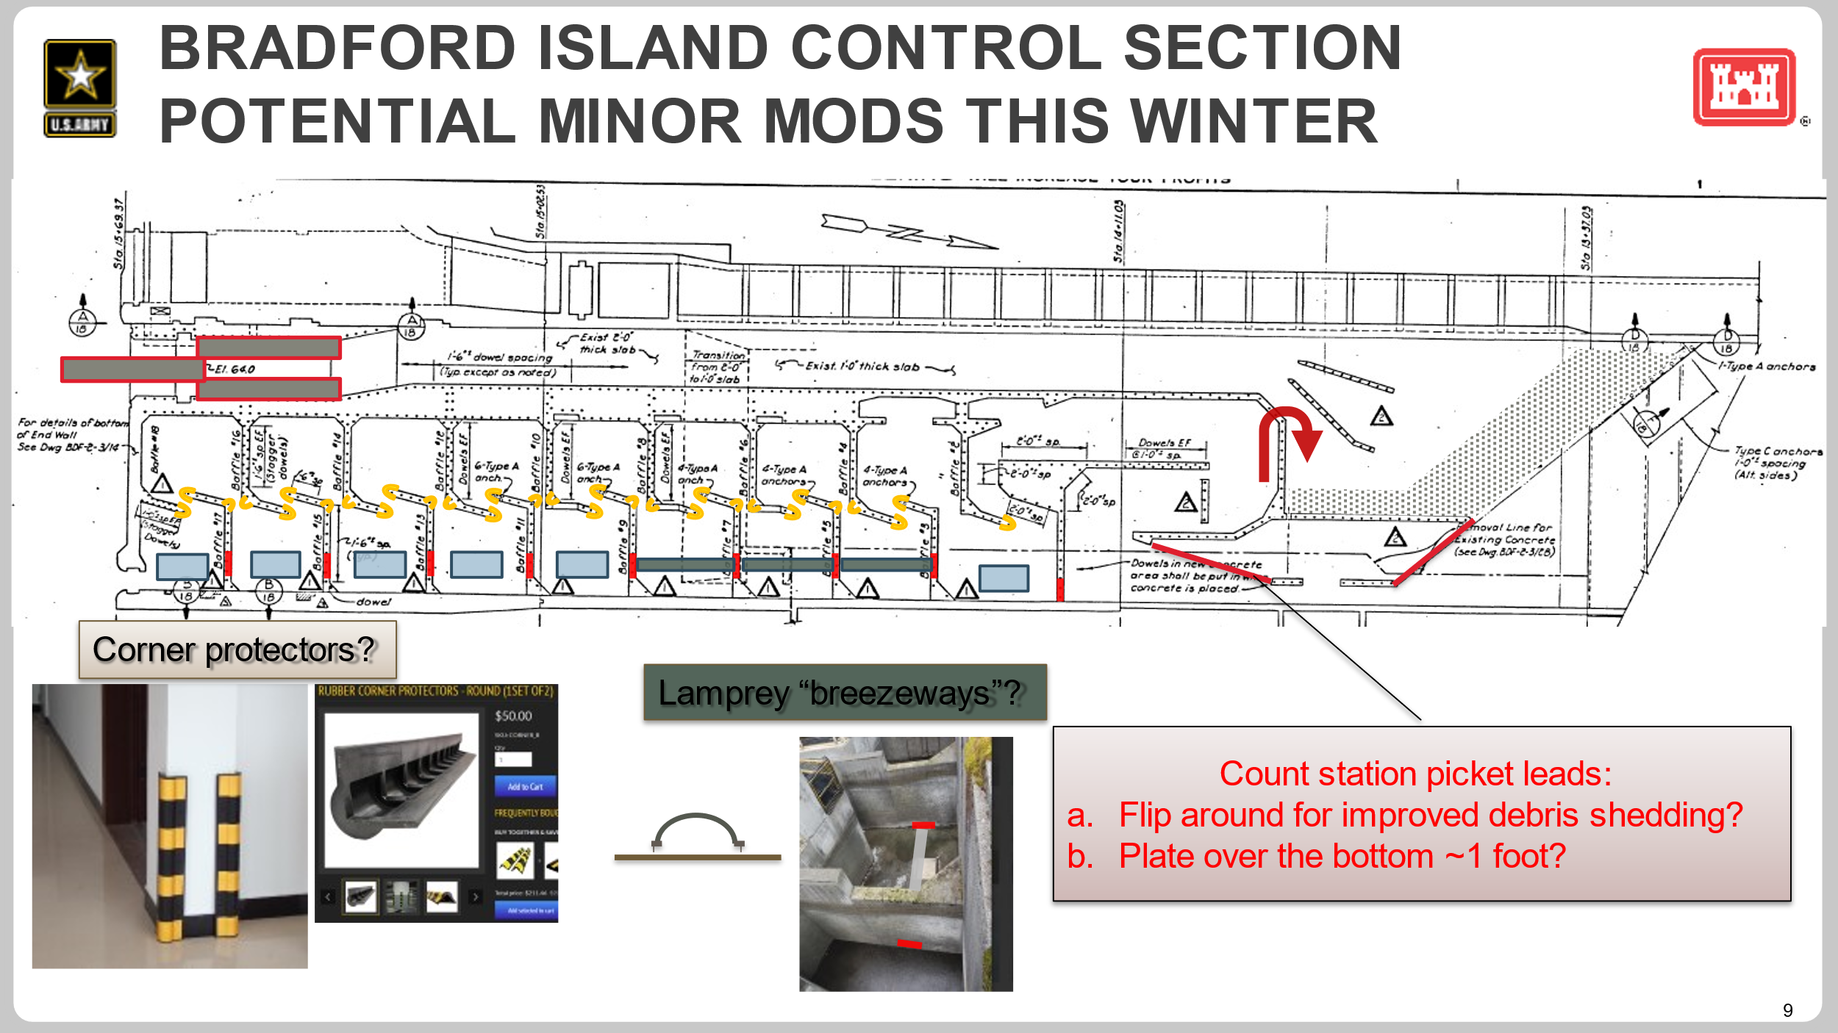
  - ACTION: Jake/Andrew will find out if we can we round the bottom of baffle corners *and* a section higher in the water column too?

Lampman: I think this could be potentially included in the "minor mods" tasks. The angle will have to be based on the head difference. I don't know the exact head difference between each weir, but potentially it could be done without the use of hoses (if the height range is manageable for the flow spillage through the surface orifice). Or will just have to operate via the flow from pipes.
  - Macdonald: Would be a modification for surface-oriented fish. Other than the wetted wall, Bradford Island is lacking extensive minor modifications for surface-oriented lamprey.
  - ACTION: Jake will ask Erin/Andrew if it’s possible to try this concept at 1 baffle in BI this year. Where is the worst baffle for lamprey passage?
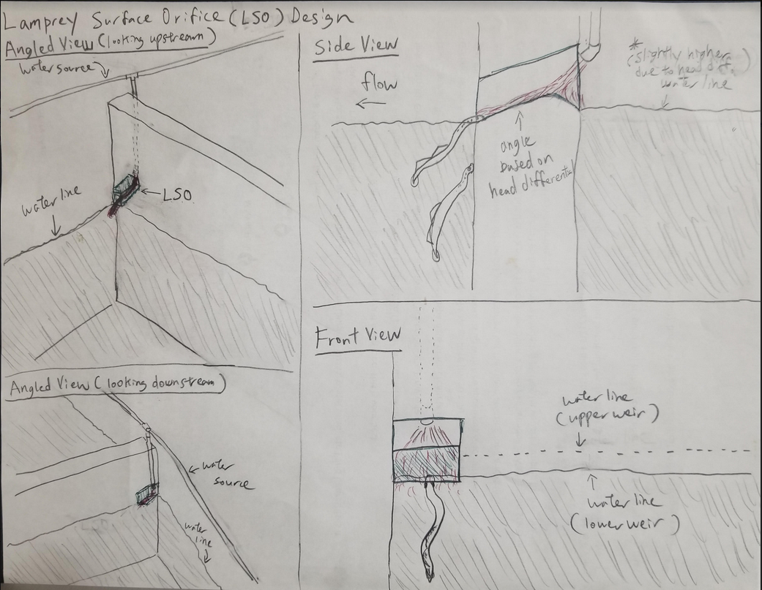

Lampman: Jim Simonson (previously NOAA Fisheries, now retired), who fabricated and designed many of the BON LPS designs, added his drawing and input below. He advised that it would be a lot easier to bore a round hole rather than a square one (yes certainly make sense). I would think a 4" diameter hole would be plenty large as adult lamprey use 4" pipes to move long distance upstream (so a short distance like this should be easy for them). He also suggested boring a hole from the top of the concrete to allow water to move straight down the opening without using external hoses that dangle down. (although this may be tough if it is a long distance down to the water level). He also had another idea about placing rounded caps on top of the weirs and placing small amount of water on top to allow lamprey to climb up and move to the next weir. Very similar to weir caps except that it is bringing in water to allow lamprey to pass areas that would normally not be inundated with water, which I thought was a great idea.
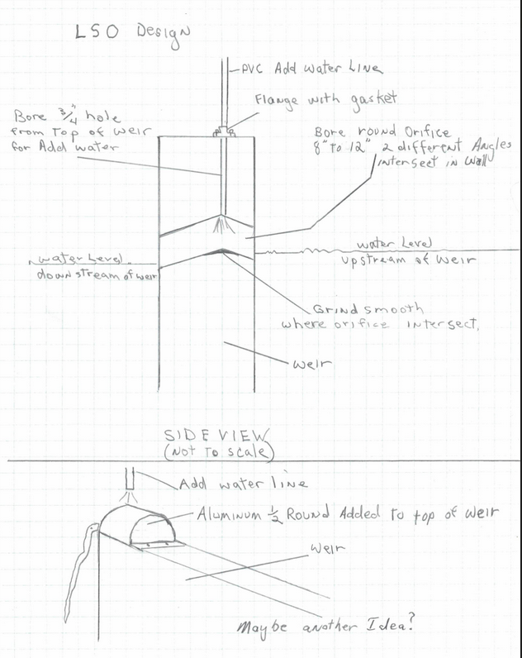

Bonneville 2nd Powerhouse Control Section Redesign (Macdonald/Kovalchuk)

90% DDR and Plans available on FFDRWG website: https://pweb.crohms.org/tmt/documents/FPOM/2010/FFDRWG/FFDRWG.html
  - Send comments to Jake by end of December.
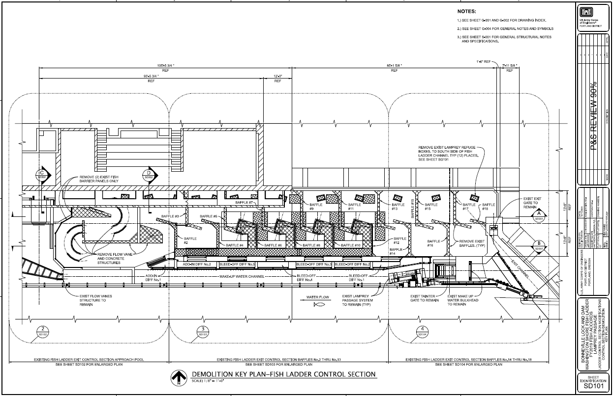
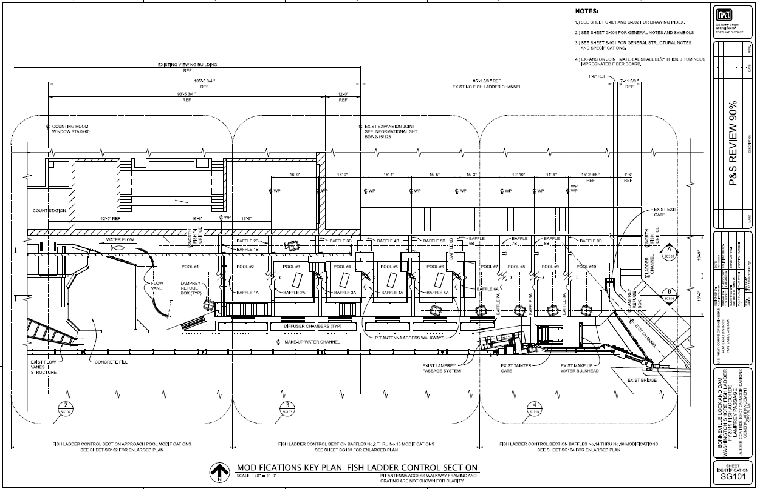
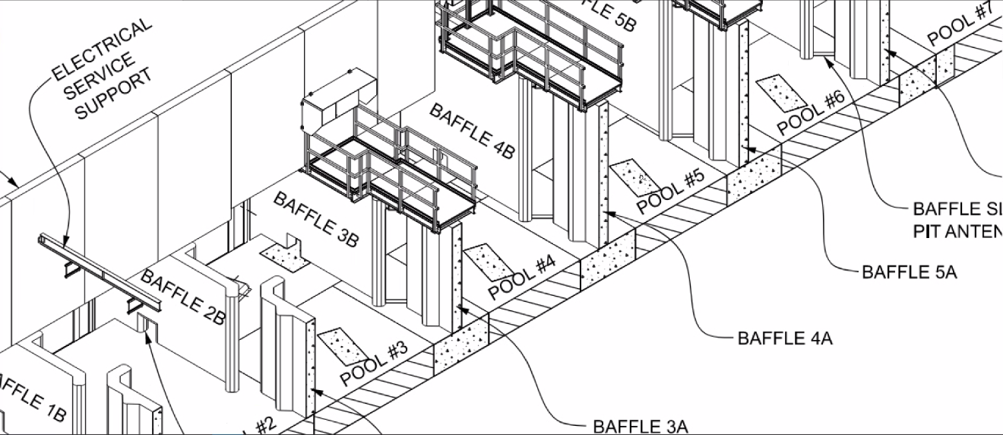
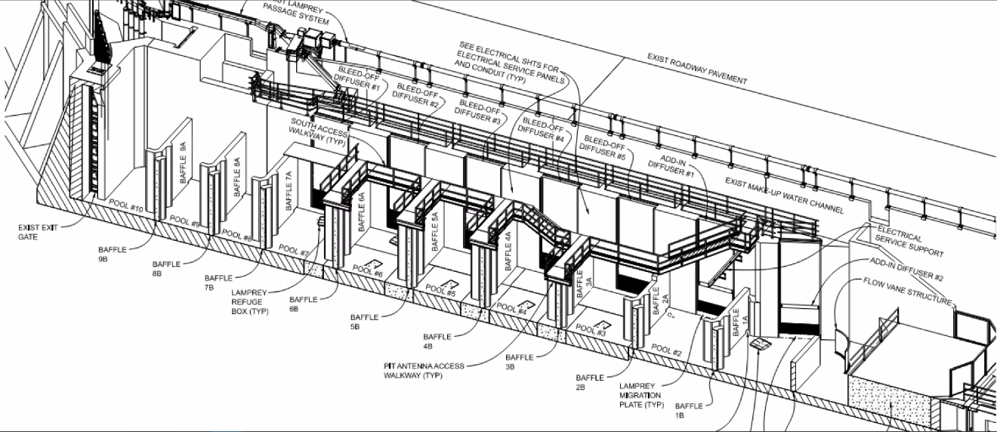

The Dalles Adult Passage Improvements (Macdonald/Kovalchuk)

90% DDR available on FFDRWG website: https://pweb.crohms.org/tmt/documents/FPOM/2010/FFDRWG/FFDRWG.html
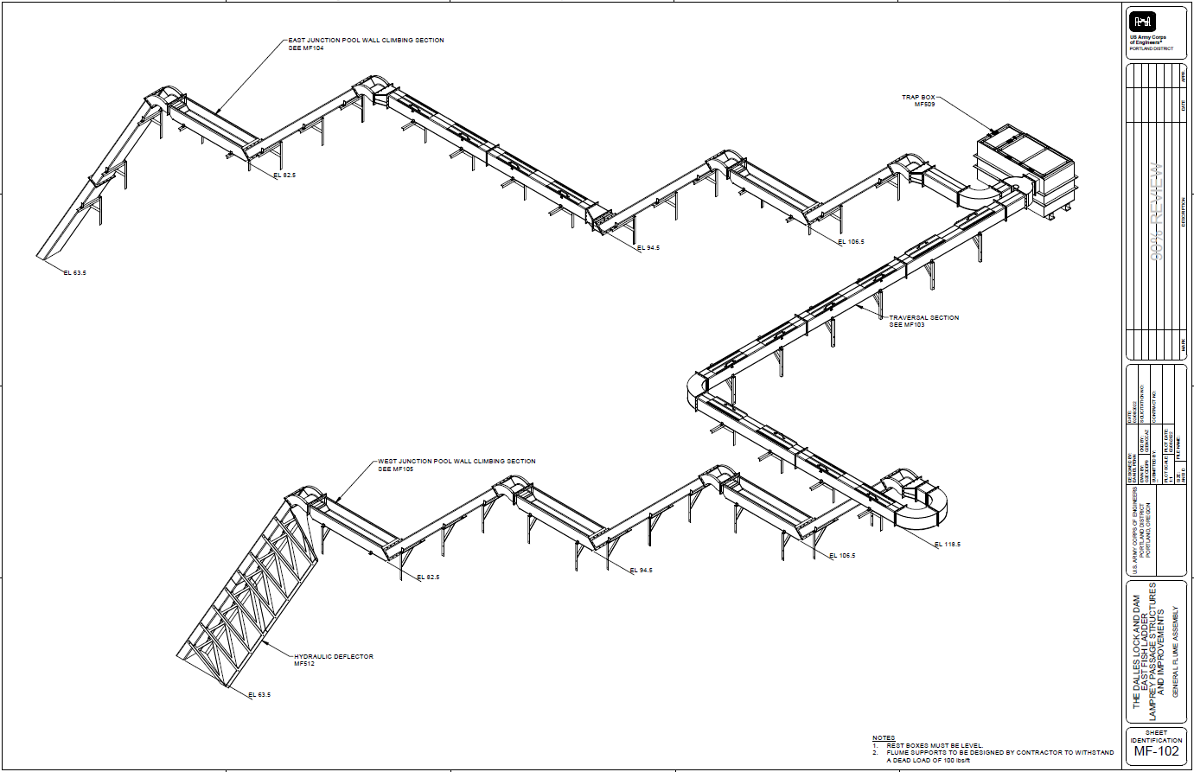
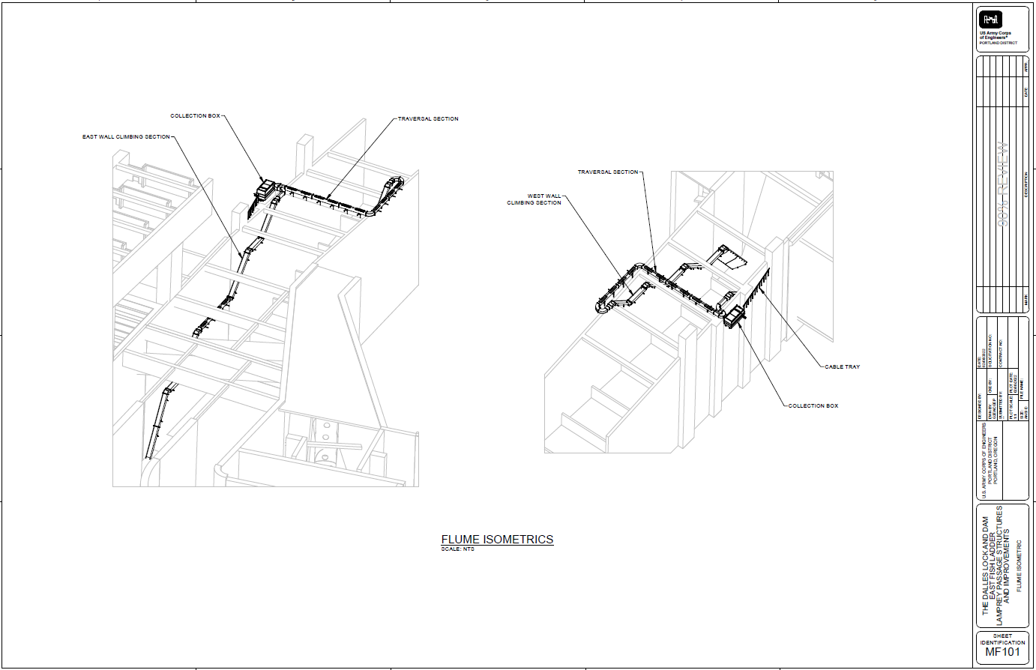

Lampman: I would like to fully discuss the entrance gap filler - what is the current issue and how to move forward.
  - Macdonald (via email on 10/16/23): The bulkhead slot fillers we designed were giant 3 piece frames with multiple crossmembers in the flow. We showed a picture of them to FFDRWG on November 3rd and nobody liked them (see attached 20221103 FFDRWG notes), look for the red “X” on page 3). We couldn’t come up with a design that did not include crossmembers within the schedule so we dropped that item from the current construction contract. We will still be covering the 3 telescoping weir guide slots at all The Dalles entrances with our 2020 Accords funding but we’ll need to develop a better (buildable) design for the bulkhead slots in the future. Also included in these notes (on page 1) is a little discussion over variable width weirs at The Dalles. If we’re going to put a giant 3-piece frame in there, I say we make it a variable width weir instead of just a slot filler. We’ll talk about this when we’re planning for future projects (2025 and beyond) at the quarterly meeting.
Referenced excerpts from 11/3/2022 FFDRWG notes:
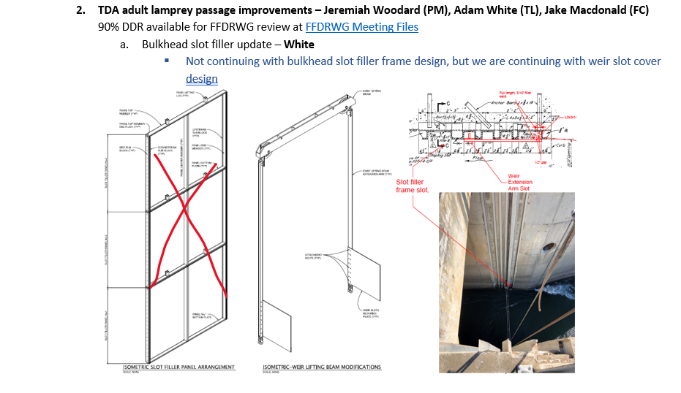
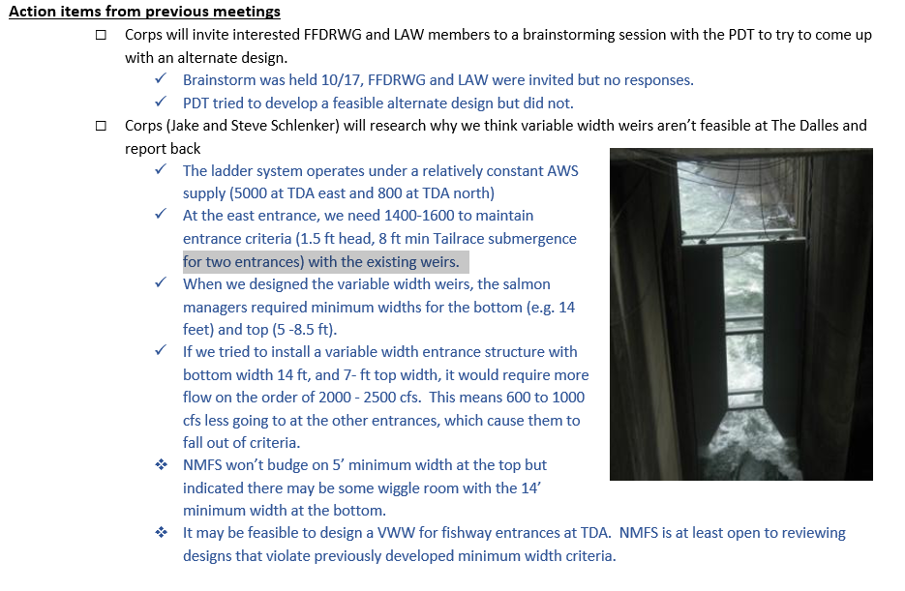

John Day Adult Passage Improvements (Macdonald/Kovalchuk)

90% DDR available on FFDRWG website: https://pweb.crohms.org/tmt/documents/FPOM/2010/FFDRWG/FFDRWG.html
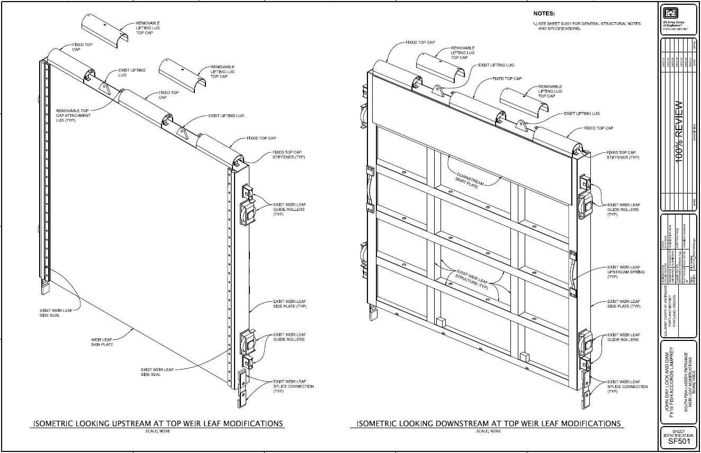
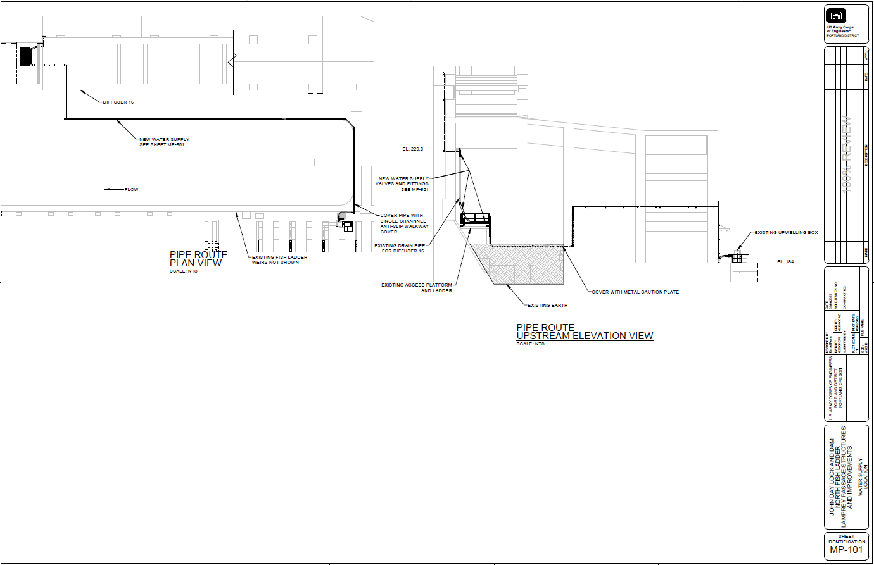

McNary Adult Passage Improvements (Juhnke)
  - Done
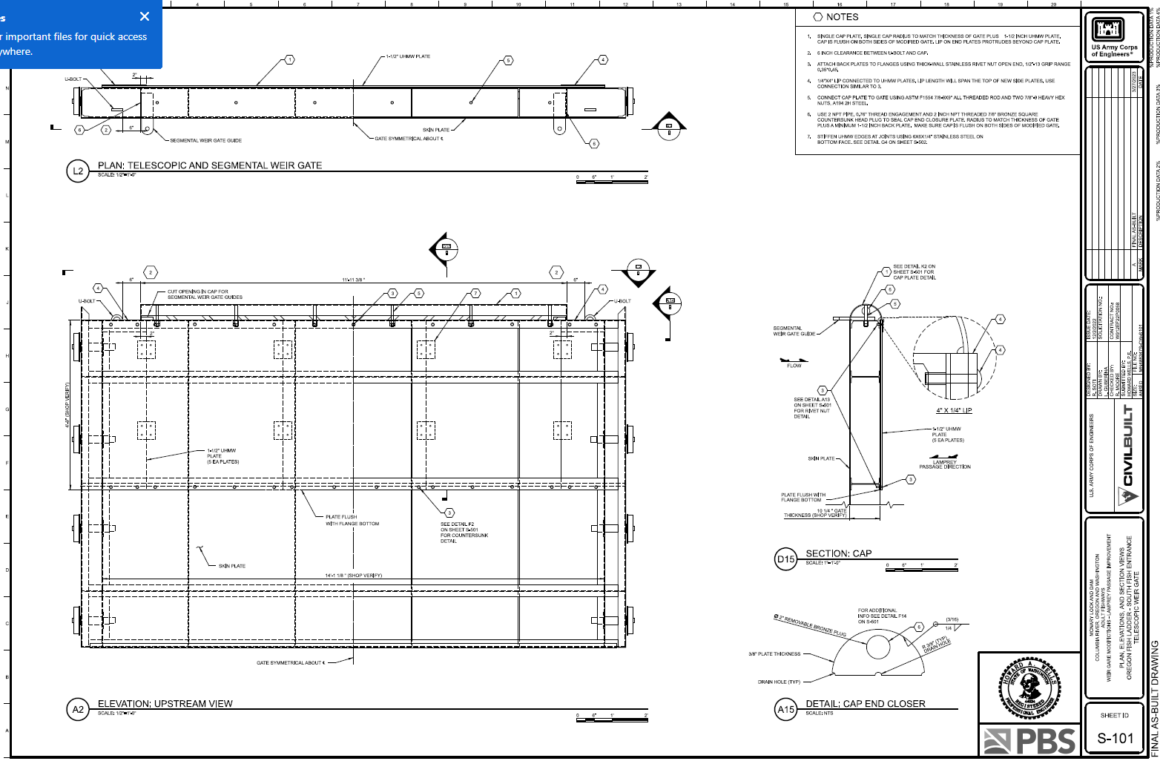
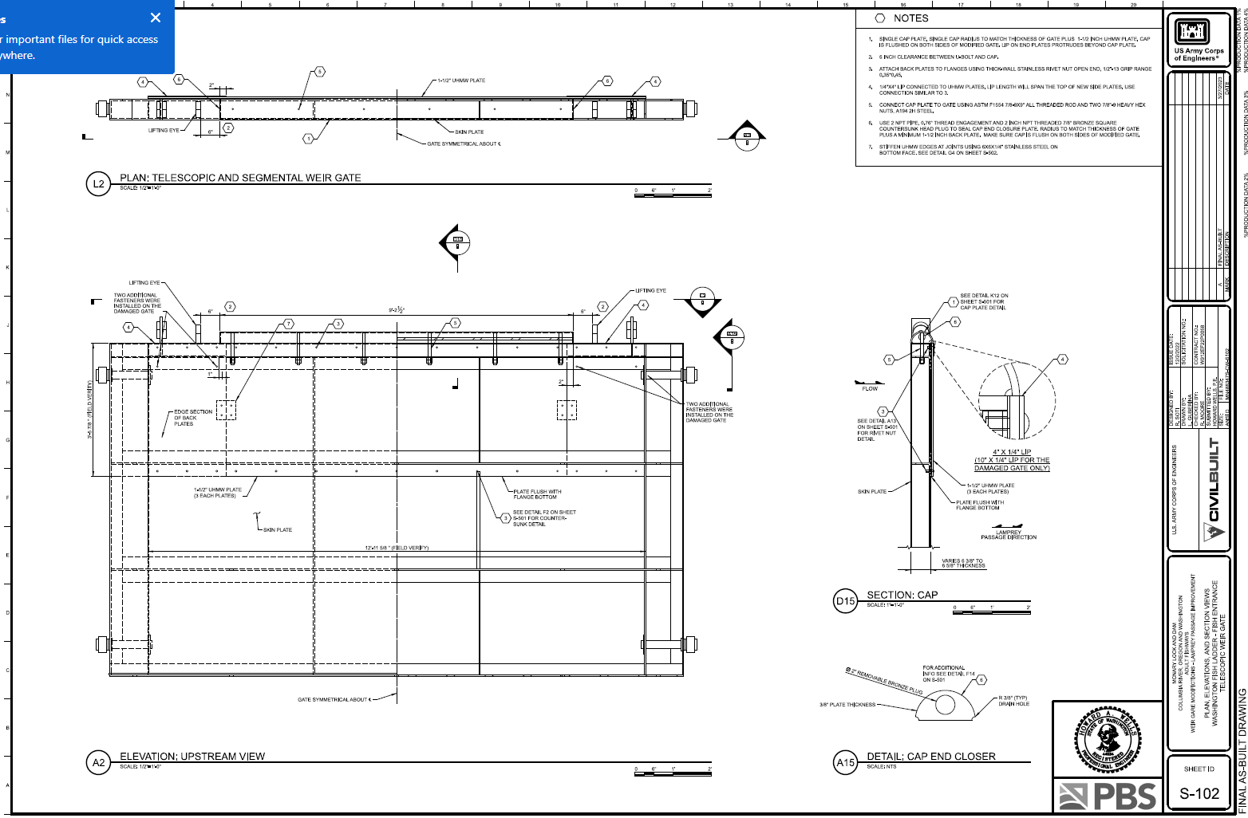
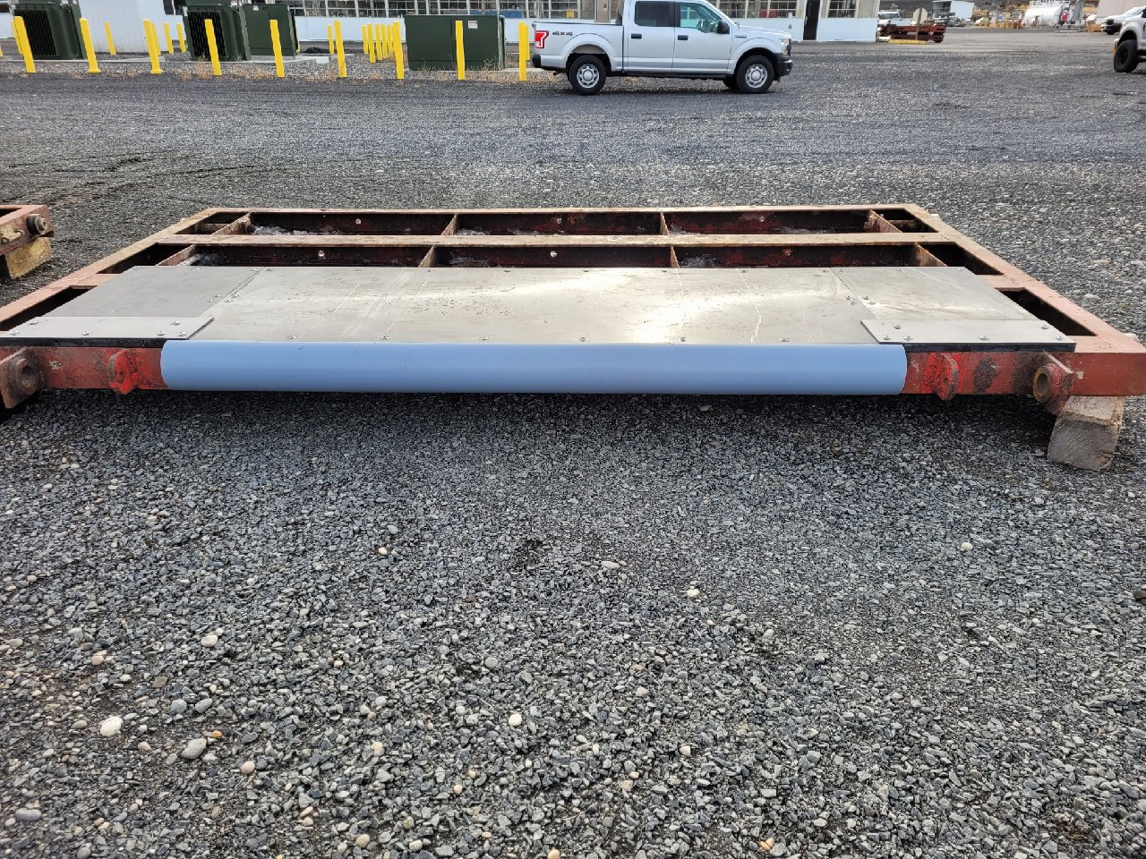
  - ACTION: Liana will investigate whether the caps extend all the way to the ends of the weir past the lifting eyes and report back.

Adult RM&E

Planning for study to begin in 2025 (Macdonald)

ACTION: Jake Macdonald will prepare an adult lamprey passage research summary for the FY25 Anadromous Fish Evaluation Program (AFEP) planning cycle scheduled to begin in February 2024. Objectives to be included holdover rates (where and how long). First detections many years are at upper dams, not Bonneville.

DAY #2: 2025 (and beyond) implementation strategy

Improving communication and coordination within the LAW

Walk through attachments LAW communication norms.docx and CRITFC Tribes Communication Goals and Challenges.docx with the team (Tackley & Porter)
  - ACTION: Sean and Laurie will work together to combine these two similar documents into a single comprehensive document and distribute to LAW for comments.

The group identified a list of communication challenges we’ve encountered, and brainstormed potential solutions for them:
Challenge | Solution
Lacking a calendar of events and milestones | Develop a quarterly calendar of meetings and events. Who should be there? Lamprey task group webpage on the FPOM site or CRITFC webpage?
Capturing meetings/communications between quarterly meetings in a record. | Keep a running list like the example below. Jake to maintain and send out regularly. ACTION: Jake will develop a list and send to LAW for comments on the format.
FPOM/FFDRWG/SRWG/SCT meetings are long and we never know when lamprey topics are coming up. | Dedicated time for lamprey topics in regional forum meetings. Put lamprey up front in FFDRWG, talk to Tammy about FPOM.
Consistency of messaging (Tribes perceive a pattern of rosie outlook followed by disappointment) | Identification of potential pitfalls and timelines earlier in project development.
Content of quarterly meetings | Less emphasis on active projects, more emphasis on new and novel ideas. Have two “types” of quarterly meeting (current program status updates / new and novel stuff). Focus on the parts of the updates that need LAW input. Have the right people there to give feedback (ie. hydraulic engineer to talk through “napkin sketches” with us)
Floating trap “breakdown in communication” | Set realistic expectations and identify pitfalls from the start. Yesterday’s clear conversation was a good solution.
Messaging in FPOM/FFDRWG is sometimes not consistent with what the group agrees on | Teamwork, mutual respect, frequent communication (formal and informal) within our workgroup
Transparency in Corps process | Keep messaging topics like the budget cycle. Timelines are key. Flag when things need to be elevated. Master timeline (dams, dates, dollars)
Coordinating “out of cycle” initiatives (floating trap, predation, etc.) | Create a decision tree for new initiatives.
Access to SME’s at ERDC | List of available models at ERDC. Investigate ERDC capabilities and seek applications for lamprey. Reinvigorate a program of passage R&D.

Porter: Suggested maintaining a tabular communication record like the table below:
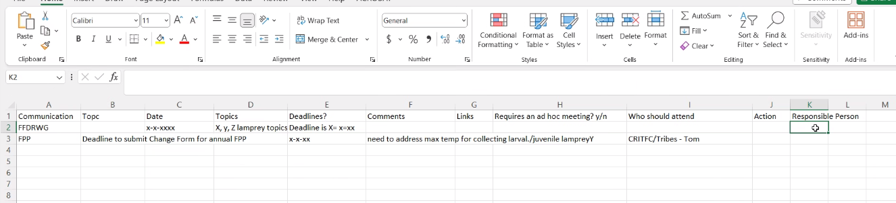

Conversation as captured by Laurie Porter, unofficial LAW stenographer:
  - ST – we should have a running table of what meetings are happening over the next 3 months, and what are the key milestones for those projects , summarize it in the table. Easy quick reference.
  - AJ – Where would this be housed? Would it be on a Corps website, or Google Drive, or how?
  - JM – we could do it at the bottom of the meeting – look into having a webpage on the FPOM website similar to what we have for FFDRW etc. a CTLAW page.
  - EK – talk to Tammi, it would not be interactive, as DOD a lot of regulations.
  - AJ – a website we can go to and click on the calendar to see what it upcoming.
  - EK and Jake M will approach Tami about setting up the CTLAW page.
  - ST – and still add it to the bottom of the meeting notes.
  - RL – envisions a separate word document that has all the meetings that are coming out. It gets updated as we get more info. An email gets sent out each time it gets updated.
  - Ralph needs something in addition to a calendar, a word document that gives details on what is being discussed, the communication that this topic will come up and we need this kind of input and feedback. That is the information that Ralph needs. Somethings will require a pre talk to coordinate what we are going to discuss at FPOM, don’t want to go there without the coordination don’t want to appear that we each are saying different things, wants to have the communication beforehand, needs a Google document or something that we share through email so we know what is upcoming and what expectations are. Those things are helpful.
  - ST – if we are meeting quarterly there are a few meetings between meetings (not a lot). If we have a table up today that is populated with information and date. Jake Erin Steve know where they are, as far as review, they can populate what the topics are that are going to be discussed.
  - ST – minimize ad hoc meetings but for some topics we may need a premeeting for some of these topics. While reviewing the quarterly calendar we can populate the docuemtn.
  - RL – We should have an interim document that covers all the key communication needs between the quarterly meetings. Outline of the important meeting dates. As things come up, put the important communication in there. Then we see things as that gets developed, it could be a Google document that anyone can provide feedback. Helps us stay up to date on what is going to happen. Things pop up. Some things we need to communicate on the fly. It would be helpful to have a Google document that highlights in between qurelty communications related to important dates.
  - TS – can we have a link to the live document that Ralph is referring to, a living document where edits and side bar discussions are going on.
  - ST – worried about it being a beast of thousands of pages
  - TS = yes it would be, but it would be something for reference, at a glance reference.
  - JM – the challenge is capturing quarterly meetings in between our meetings lamprey related
  - ST – lamprey related
  - TS – I like the FPOM format, at a glance you can see where you want to go and then dive deep into whatever subject by clicking on a link.
  - JM – the thought of updating a Google document on a website. How often are we expecting JM to go in and update this document?
  - LP develops draft excel sheet with columsn that RL would like to see
  - ST – prefers that it does not become something like quasi meeting note log where we start going back and forth. It would be extending some of the email that we have had and put in this simpler format. Reference sheet to know when key engagements are coming up and if there is a need for ad hoc meetings.
  - ST – some unusual topics (floating collecter, etc.) are the only type of things that are not predictable. Others are predictable.
  - Key budget discussion that the Corps needs feedback from CRITFC/Tribes on a key milestone or issue we are grappling with.
  - LP asks if Lamprey can have their own designated time at all meetings.
  - LP will ask Tami re Timed item for lamprey at FPOM
  - All other meetings Jake and Chuck will go ahead and make lamprey topics a timed item upon consultation with the other team members.
  - FFDRWG tends to be all lamprey topics at this time. ACTION: Chuck and Jake will put all the lamprey topics up front at future FFDRWG meetings.
  - Chuck agrees this is a great idea and will do that.
- Jointly develop and follow communication protocols.
- Transparent communication from and between CRITFC/Tribes and Corsps. don't want the Rosie outlook at the beginning, only to be followed by "this won't work now and by the way it is also too late" (help us make the important incremental steps so that we see the hurdles and challenges at the onset so we can work through those step by step - not at the 11th hour
- RL – consistency in the messaging from everyone and make sure the steps are lined out clearly. Seems like we hear what is a solution or way to get around things, then we do it. But then …step by step help on how to get there, early on, not late in the game.
- ST – we have to acknowledge up front when there is something that is ‘new’ ‘unchared territory’ the Corps should pause, give them time to think through the solutions on how it can get done.
- AJ – at times wer hear an idea, everyone hears it is possible, then we find out there is a lega issue or other issue that prevents that
- ST = recognition when the ideas come up there is a desire to do things as wuivkly as possible – there should be a commitment on the corps side to provide those answers intimeleiy manner
- AJ-Time is of the essence.
- ST – breezed through agenda yesterday on the normal crfm topics we are speding most of our back and forth on these unusual topics. Colelctively recognize these new things are discussions. Acknowledge that up front rather than setting expectations that we will do it.
- AJ – need to make time for brainstorming ideas, were not committing to anything right now, but we are brainstorming, not necessarioy saying we can do them. It is nice to have a sit down. The Agenda is just getting ideas down on paper. Saw a number of ideas yesterday from Ralph and Jake and Kyle.
- AJ - Make appropriate time for those meetings. It used to be 2 full days, then implementation started happening so it went to 1 day, now 1 ½. Sometimes it is important to have a 2 day.
- JM – solution for the quarterly meeting agenda, less empahisis on status, more emphasis on novel?
- AJ – no, we want both. We want a quarterly update meeting, and another meeting for sitting down to think of innovative and novel stuff.
- JM – what about every other meeting?
- AJ – both are need to happen.
- ST – early designs, eg 30 % edr, or alternatives phase, that is the most important time to get all ideas on the table to flush them out. Dot I cross t. We need to make sure we are engaging in heavy discussion at these LAW meetins on that even though they are discussed at FFDRWG too. Shapes solution we are investing in.
- RL- when we are getting updates, if we can focus on the part that could use input. Mabye there isn’t much on some things that needs input, we want to focus on those things as they are doing update.
- AJ – consistent email updates of anything something that changes quickly. For example the lamprey item Laurie and Ralph wanted to attend and missed it, they changed it to first thing. Get those emails out even last minute emails so we know.
- RL JM – email 15 minutes before the meeting started so unusual but going forward will do it.
- AJ – it is hard since we are all doing things at different times so hard to get us lined up same day same time. Time is precious.
- LP – discussion regarding floating trap and predation communication breakdown.
- LA – agree with what laruies is aying, Liana met with similar frustrations during some of the meetings and found it difficult to follow what the processes are fro some of these , working on an SOP (for herself) that tackles hurdles for introduction of new projects . Sometime is is clear on who we need input from for each project type, how long the inquiries might take, wonder if that is an application for this issue to minimize frustrating surprises?
- JM – Jake didn’t see the communication breakdown with the floating trap, Jake feels we have done a really good job of finding a place for the floating trap, changing schedules for testing in the CBB building. Don’
- RL – want to focus on solutions. Agree with what Laurie said. Flip flop is the frustrating part that we have to deal with. This is going to work, the next minute this isn’t going to work, we didn’t have the appropriate check in to work through it. If we worked together to get therough the issues it would have gotten to it more quickly. Our fault too, we just need to figure out what protocols we need to put in to work together better.
- AJ – make sure when we talk about an item at FPOM or FFDRWG make sure that the message is a message that we agreed to. EG put a trpa here put a trap there or collect fish here or collect fish ther. Agree with RL lets move forward and put this behind us build a stronger team. We have each other’s back. Build the strong foundation ive seen the group had I the past. The Corps could help us to understand better and help us to not have miscommunication or misunderstandings. Sometimes you don’t want to bog us down but we need to understand what those things are. If We don’t know what the challenges are we cant help improve things.
- TS – key concept is transparency. Sometimes the Corps processes is a monolith or wall. TS senses increasing attempts to explain the concepts, especially in regards to budgeting and how far out in the future things are planned. As soon as possible, flag things and layout timelines. Timelines are critical. Lamprey – one word – urgency. We say fixes instead of improvements. We like the Crops to know and understand the language. Get the Polciy folks to the dams and travel to the homeleand remote areas so they appreciate the struggle it is to get the fish there. Timelines and transparency. Once of the frustrations you are hearing is it is like a looped tape, you keep hearing the same thing for decades. We do see a trend it is increasing which Is great but we are still not there we need hundreds of thousands and millions. Not thougsances. Transparancy and Timelines. Where the Corps can help us is flagging when we need to elevate things to policy levels. So much of it is just going to come down to money. Understanding the Corps budgeting process and as transparent as Corps can be let us know as early as you can as to when we need to elevate. Corps jprocess is in low gear. The tribes are in overdrive because that is the need. For NPT , harvest, that is theoretical.
- JM – the Corps process is cumbersone and difficult to work in. Corps wants us to appreciate their difficulties working within this process and trying to get things done within the Crops system. COprs is like lamprey trying to work through the control system.
- TS – one thing that would really help is a Master Timeline, with Dams and Dates and Dollars. Where we need the dollars, what dams, and the dates. It is going to change but it gives us a framework. Especially when we elevate it to policy without a lot of verbiage and flowery words, this is the reality. Allow them to interface and jump in and do what they can in their limited time frame.
- ST = when Liana was talking about an SOP of somewort, the topics where there have been mis signals is if we had some sort of common understanding of a decision map. If there is a new idea out there that the Corps doesn’t say 100 percent or the scope we can t do this year, lets add to the que. Having a common understanding of that these are the things we need to figure out before we say Yes. Saying that to the Corps and the tribes. So we don’t set the wrong impression and go in circles. Simlar to the 30 % design. Go slow to go fast. Walk through it at 30 % does the corps have the authoritye is this something we have funding for , is it an access thingt to do something on corps property , what is the lift the corps has to provide, do we have funding, have a person at the corps repsonsbilty for following up on answering the questions in a timely manner.
- AJ – I like that. The first one is does the corps have authority to do it? Then we hera No . then there is no follow up as to how or whay the Corps is a No . then think creatively and inovativel yas to how do we get this done. Is ti above our level and do we need to go to Polic (all of us, Corps tribes0.
- ST – for example decide when we want to go to others. Do we really need to ask office of council if we have authority to do a thing. Taling through all of those things and almost a checklist or key anytime a new or outside the box thing that we all have in t
- We used sit down and try to figure things out and spend half the meeting brainstorming and getting others expertise.
- AJ – we used to have travis in the meetings and he had great comments. We should have a mandatory request to have Travis or someone like that to help us float our ideas.
- ST – will help us work on that, how to navigate the new things so we are consistent about it and tet the answers.
- TS = we talked reently about the gray areas, we are often in the gray area, if we are in the realm of a napkin sketch, as early as possible when you realize that this is going to be something that you are not sure where yo are going to take it in your agency. Flag that. Everyone in the room will know this is an area that may need to be elevated as soon as possible. RD to OM. As soon as possible Flag that for us so we can take it to our policy or we can take. Get policy out to the sites. Etc.
- ST – sketches of drawings, ideas, etc. if we talking about a structure at a dam that we are going to operate and maintain, we should bake that in the O and M of that. In addition to the dams and dates, need to understand the process for quieing up a project for design. That might mean slowing down to test at a smaller scale and how to integrate it.
- AJ – we can’t slow down on the concepts we have to continue to build that stack and folder of concepts. We have to continue to think novelly.
- ST – we can keep notes on ideas even if we don’t have funding in hand to start a project.
- AJ – it might be useful to have within the FPOM folder a brisntorming folder that captures that. It is in the notes.
- TS – be cognizant of available resources, what tools do we have in the tool box? What about the Corps lab in Mississippi? Some of these concepts, when those places have time/avialablitly like Ralphs drawing, speed bumps, etc.
- AJ = what are they working on now in that lab, ther was a model at McNary? We need to see a list of models.
- TS – the screens, we look at sketches that explained hydraulics, is there anything that lab can do.
- JM – kyle presented yestedary on the laboratory work that the Corps is doing. And he is doing more.
- AJ – seeing the physical models were really helpful you could watch how the things functions, the McNary portanble hood, we tweaked and developed it better because of the model. PHsyically working with the thing helped.
- TS – at BON, heat diagram of water velocities, for Wa shore, showed how a picture is worht a thousand words.
- AJ = those things will help us to think more creatively.
- ST – all this work started as lab work at AFF and FERL and U of I testing design features and LPSS. The plan or idea of when we are thinking ahead, for Erins benefit, when we think from 2025 to beyond, our lesson is we probably cant execute as money prjoects as we think we can , and have a certain % of the budget allocated for R and D. (eg outside of entranced, we have a location, we have back of th napkin ideas, we could be thinking about ways (before kicking off EDR) or longer EDR phase, we could invest some dollars, call it RME or RD to develop and test ideas whether in flume at BON etc. or a physical model CFD model with ERDc, invest more time and % of the budget to continue our need to test the ideas like pucks or what Ralph s sketched out. Test before we vuild something. WE used to do that. WE switched. Using inormiaotn that we gained in the lab from 20 years ago. Might be time to reinvigorate.
- AJ – we might need refinement, like lamprey smart panel, etc. new technologies that have come out since 2008. Physical models and conceptuals models in the best way possible.
- ST – we need a way to test thes novel things and should build into our planin and budgeting.
- TS – one additional thing is background frustration that could be part of our frustration is Lampreys junion status to Salmonids. The Corps as much as it is an agency it is an institution with institutional inertial. We are doing, we are in the process, but pivotoing to where as much as possilb eLamprey are on equal footing with Salmon. When we see and hear that the coprs can use the tools they have some top of the line, when we see it on lamprey it goes a long ways towards the good faith. It is exciting.
- AJ – as the Corps starts showing that, then it brings the other federal agency, they NOAA or others sometimes don’t like what we develop they worry about 1 fish jusmpign atit.
- TS = science, exciteing, validation of the work we are doing. What we need now is the institutional shift where we see what you are talking about, frustration is communciatons we already know that some federal agency with trust repsonbiliby with repsct to the treaties and its going to be no and it is unacceptable.
- AJ – at this level this group has been pretty good at that, it si the policy makers that we need to elevate this to your superieor and they should tell their superioroe that lamprey need to be elevated. All fish including lamprey are equal holisitic view from day one grew up learning that very thing that is ingrained in everyone fo our tribal people we have a mission to carry that out.
- TS – it is starting, at the federal level USFWS every species is important whole ecological approach not just species by species approach. Key perspective. Getting ther. We are asking you in your positons when you see an opproutni moment with someein in the agency when it is an opportunie time for them to be at a meeting and hear it lets see if we can have them here to interact to see what the challenges and opportunities are to move the ball down the fields.
- CRITFC/Tribes will provide comments in a timely manner, meeting deadlines.
- Clear and concise communication from the Corps to the CRITFC/Tribes.
- Clear and concise communication from the CRITFC/Tribes to the Corps.
- Corps will track and incorporate suggestions and comments that they receive from the CRITFC/Tribes in a timely manner, meeting deadlines.
- consistency in messaging (we hear different takes/perspectives from different staff and this is very confusing to us)

Summary of potential focus areas for 2025 and beyond
(Revisit the list of actions we developed ~2018, add new actions as needed, reprioritize the list, and continue penciling out a plan to inform USACE budget requests 2025 and beyond)

Work through CTLAW_Priorities (17-NOV-2023) spreadsheet (Macdonald)

Add new actions as needed.
  - The Dalles Variable width weirs
  - Juvenile/larval/adult RM&E
  - R&D (Lampman entrance structure, other novel design ideas, ELAT modeling for lamprey)
  - Predation study & tailrace collection

Reprioritize the list. (Save for 12/15 priority recommendation meeting)

Distribute our priorities over the next 5-year period (2025-2029) into an executable 5-year plan (remember 2018-2020? “Coordinated with Tribes and CRITFC developing and prioritizing a list of actions, should funding be received”). (Save for 12/15 priority recommendation meeting)

Current working list of the actions that will be completed under the current implementation plan, actions we had planned to complete but won’t, and other work we could do if we had more funding in the future.

will be complete by end of FY24
Juvenile Passage and Migration RM&E Plan (2022, 2023, 2024)
BN1 BI serpentine extensive minor mods (2021, 2023)
BN1 B-Branch entrance improvements (CRSO)
BN1 B-Branch orifice ramps and diffuser plating (CRSO)
BN2 CI orifice ramps and diffuser grating plates (CRSO)
BN2 WAS control section redesign (CRSO)
BN2 WAS LFS modification
BN2 WAS LPS pump upgrade
BN2 WAS wetted wall (CRSO)
Improve Adult Counting at BON LPS's
JDA NFL VWW plating
JDA SFL collection and counting improvement
JDA SFL LPS (CRSO)
JDA SFL SE1 weir improvement
JDA NFL entrance LPS improvements (CRSO)
MCN weir caps (CRSO)
ICH turbine cooling water strainer (CRSO) design
TDA EFL elevated orifices in exit weirs 154-157
TDA EFL Junction Pool LPS (CRSO)
left to do from FY20-FY24 plan
Juvenile Passage and Migration RM&E Plan (2025)
Adult lamprey passage & migration RM&E
BN1 BI LPS pump upgrades
BN1 BI serpentine extensive minor mods (2025, 2027, or 2029)
BN2 CI LPS flume modification
BN2 WAS Transition Pool LPS (CRSO)
Diffuser Grating Assessment
ICH turbine cooling water strainer (CRSO) installation
McNary Diffuser Plating
LMN NFL diffuser grating plating (CRSO)
proposed future work
Adult lamprey and salmon behavior at BON WA Shore Collection Channel/FOGs - assume hydroacoustics/imaging (PLACEHOLDER)
Adult lamprey passage post-construction study; migration behavior/fate study; evaluate "shad mode" (BON, TDA, JDA)
Adult lamprey passage R&D study (assumes BON AFF/FERL for lab testing weir cap design; field test w/ video at ~3 weirs)
Adult lamprey trap-and-haul feasibility study (PLACEHOLDER)
BON Bradford Island Ladder A-Branch (B1) LPS/Collection Structure
BON Bradford Island Ladder Control Section Minor Mods
BON Bradford Island Ladder overflow weir section - rounded caps/wall attachment surface - (lab test > field test > full install at 1-2 ladders)
BON WA Shore Ladder FOG modifications (structural/operations) - support RM&E to test/modify FOGs (PLACEHOLDER)
BON WA Shore Ladder Junction Pool LPS ( incl. NDE entrance/LFS mods/collector)
BON WA Shore Ladder overflow weir section - rounded caps/wall attachment surface - (lab test > field test > full install at 1-2 ladders)
BON WA Shore Ladder SDE LPS/Collection Structure
Develop 2026-30 Interim Lamprey Implementation Plan (incl. annual updates/reports)
Develop 2031-50 Comprehensive Lamprey Passage Strategy/Plan (incl. annual reporting)
IHR North Ladder - Entrance weir caps (4" radius)
IHR South Ladder - Entrance weir caps (4" radius)
IHR Turbines - Install exclusion structure at 1 additional unit, following prototype testing
JDA North Ladder LPS - Convert to volitional structure to 180-deg bend in ladder (retain collection capability)
JDA South Ladder - Modify/plate over wall diffuser near SE1 entrance
JDA South Ladder - Remove up to 3 lower ladder weirs (pending hydraulics review, NMFS coordination)
JDA South Ladder LPS (entrance/junction pool) - De-prioritize
Juvenile/larval lamprey passage RM&E - assume acoustic telemetry study at 1-2 dams to address specific mgmt. questions
LGS Juvenile Fish Facility - Design/install structure (portable wetted wall?) to prevent lamprey downstream transport
LGS Ladder - Entrance weir caps (4" radius)
LMN North Ladder - Entrance weir caps (4" radius)
LMN South Ladder - Entrance weir caps (4" radius)
LWG Ladder - Entrance weir caps (4" radius)
LWG Ladder - Modify picket leads to force lamprey through count slot
MCN North/WA Shore Ladder - Remove obsolete structures from lower fish ladder
MCN South/OR Shore Ladder - Convert 1" floor diffusers to 3/4" (incl. trash rack mods)
MCN South/OR Shore Ladder - Convert existing lamprey orifices to 1.5" openings (mandatory, per NMFS)
MCN South/OR Shore Ladder Entrance Structure - Evaluate condition; determine need for future (post-2030) mods
predation study
Study effects of hydrosystem operations on larval lamprey in mainstem
TDA East Ladder - East entrance improvements - Assume variable width weir or other larger-scale entrance mods OR collection structure
TDA North Ladder - Hydraulic design evaluation of North Ladder vs. other fish ladders (why does it perform so well?)
Update juvenile/larval lamprey RM&E plan
other previously identified actions (carry over from 2020 ranking meeting)
Bonneville Bradford Island AWS LPS modification
Bonneville Bradford Island control section redesign (CRSO)
Bonneville Bradford Island hydraulic refugia
Bonneville Bradford Island tailrace surface collection
Bonneville Washington Shore AWS LPS modification
Extend John Day North LPS to forebay
John Day turbine cooling water strainer intake exclusion
The Dalles North picket leads
intake screen projects
Little Goose intake screen replacement
Lower Granite intake screen replacement
McNary Intake Screen replacement
cooling water exclusion projects
Bonneville 2PH turbine cooling water strainer intake exclusion
Ice Harbor turbine cooling water strainer intake exclusion
Little Goose turbine cooling water strainer intake exclusion
Lower Granite turbine cooling water strainer intake exclusion
Lower Monumental Turbine cooling water strainer intake exclusion
McNary turbine cooling water strainer intake exclusion
The Dalles turbine cooling water strainer intake exclusion
diffuser grating and trashracks projects
Bonneville Bradford Island diffuser grating and trashrack replacement
Bonneville Cascades Island diffuser grating and trashrack replacement
Bonneville Washington Shore diffuser grating and trashrack replacement
Ice Harbor North diffuser grating and trashrack replacement
Ice Harbor South diffuser grating and trashrack replacement
John Day South diffuser grating and trashrack replacement
Little Goose diffuser grating and trashrack replacement
Lower Granite diffuser grating and trashrack replacement
Lower Monumental North diffuser grating and trashrack replacement
Lower Monumental South diffuser grating and trashrack replacement
McNary OR diffuser grating and trashrack replacement
McNary WA diffuser grating and trashrack replacement
The Dalles East diffuser grating and trashrack replacement
The Dalles North diffuser grating and trashrack replacement
diffuser plating projects
Bonneville Bradford Island diffuser plating
Bonneville Cascades Island diffuser plating
Lower Monumental North diffuser plating
Lower Monumental South Ladder diffuser plating
The Dalles North diffuser plating
weir caps projects
Ice Harbor North weir caps
Ice Harbor South weir caps
Little Goose weir caps
Lower Granite weir caps
Lower Monumental North Ladder weir caps
Lower Monumental South Ladder weir caps

  - ACTION: Jake will clean up the CTLAW_Priorities (17-NOV-2023) spreadsheet (remove duplicates and add actions identified above) prior to a 12/15 priority recommendation meeting.
  - ACTION: Erin/Sean will check with Ida on the timeline for 2025 budget. Will schedule an ad-hoc meeting if needed.
    - Sween: Request a placeholder in future budgets ($500k to start, increasing over time) “earmarked” for CRITFC/Tribal initiatives. Details forthcoming.

Next meetings and milestones (When? Where? How long?)

Floating trap planning field trip to The Dalles and John Day
  - Wednesday 11/29. Jake will schedule.

Next FFDRWG & FPOM meetings
  - FFDRWG = first Thursday of every month = 12/7 (let Jake Macdonald/Chuck Barnes know if you need invitation).
  - FPOM = second Thursday of every month = 12/14 (let Tammy Mackey/Chris Peery know if you need an invitation).

LTWG Info exchange 12/13-12/14, Vancouver Water Resources Center

FPP change forms are due to Lisa Wright by Friday 12/15.

CTLAW FY25-26 priority recommendation meeting
  - Friday 12/15. One-day (or half) virtual meeting. Jake will schedule.

Predation study coordination meeting
  - January. Jake will schedule and host on his Webex, Ralph will lead.
  - Get all the players together to confirm responsibilities.

FY23 Anadromous Fish Evaluation Program (AFEP) annual review
  - Wednesday, January 24th. Full-day in-person meeting. (let Jake Macdonald/Chuck Barnes know if not on your calendar).

Next regular quarterly meeting for budget updates (and other topics as needed)
  - February-March 2024, Jake will send a doodle poll
  - Avoid OR AFS Feb. 28- Mar. 1
  - CRITFC volunteered to host in Hood River. Pendleton is a nice place to have a meeting too. Next Spring or Summer, we should try to rotate up to Nez Perce country.

Mainstem RMU meeting
  - Multi-day workshop after LAW is in alignment, Sean will schedule. Laurie and Sean will work with John Netto.

JDA North LPS
  - One-day site visit in 2024, Jake will schedule

MCN/JDA Juvenile lamprey study site visit
  - One-day site visit in 2024 to observe PNNL’s tagging operation, Jake will schedule

